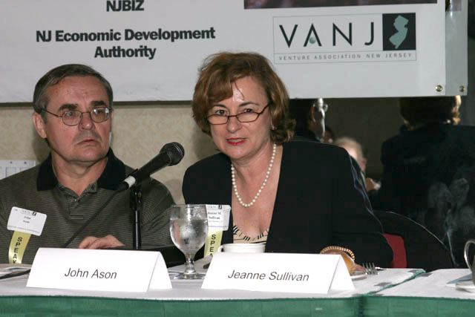
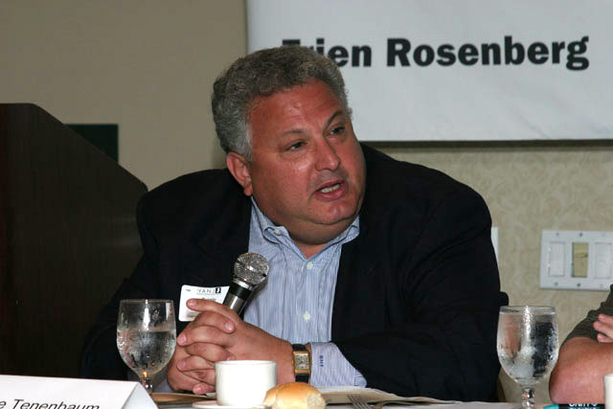
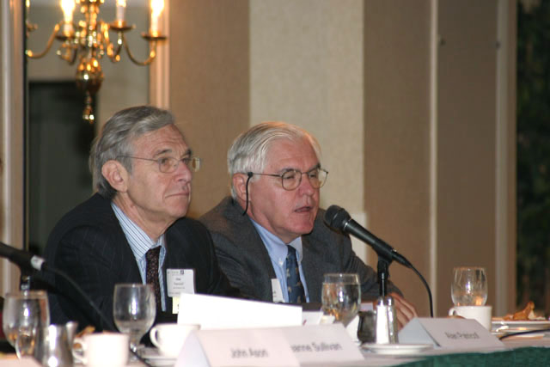
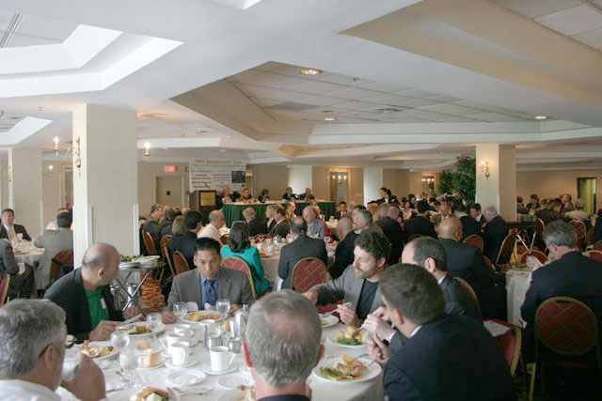
Jay Trien, President, VANJ introduces investor panelists, Bernard Tenenbaum, John Ason, Jeanne Sullivan, Alan Patricof &
Wayne Tamarelli
John Ason, angel investor & Jeanne Sullivan, Partner, StarVest Partners
Bernard H. Tennenbaum, Moderator, Former President of the Children’s Leisure Products Group (CLP) of The Jordan Company
Alan Patricof, Vice Chairman of
Apax Partners, Inc. &
A. Wayne Tamarelli, Ph.D., MBA, President, AWT Private Investments
Sold out luncheon crowd
Wayne Tamarelli, Investor, Musa Yenni, Financial Advisor to Supertron, Joe Flicek, CEO, Supertron, Tanasha Lockburn, Supertron &
John Ason, Angel Investor
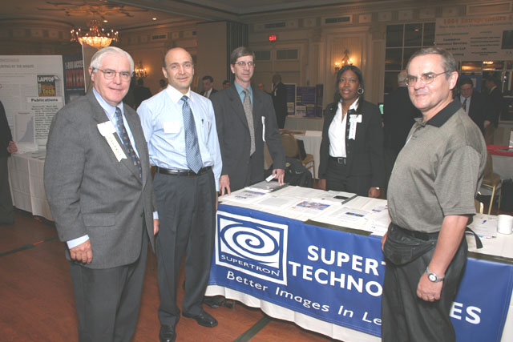

2004 Entrepreneurs Expo

May, 17, 2004
