2005 Entrepreneurs Expo
& Elevator Pitch Olympics
May 16, 2005

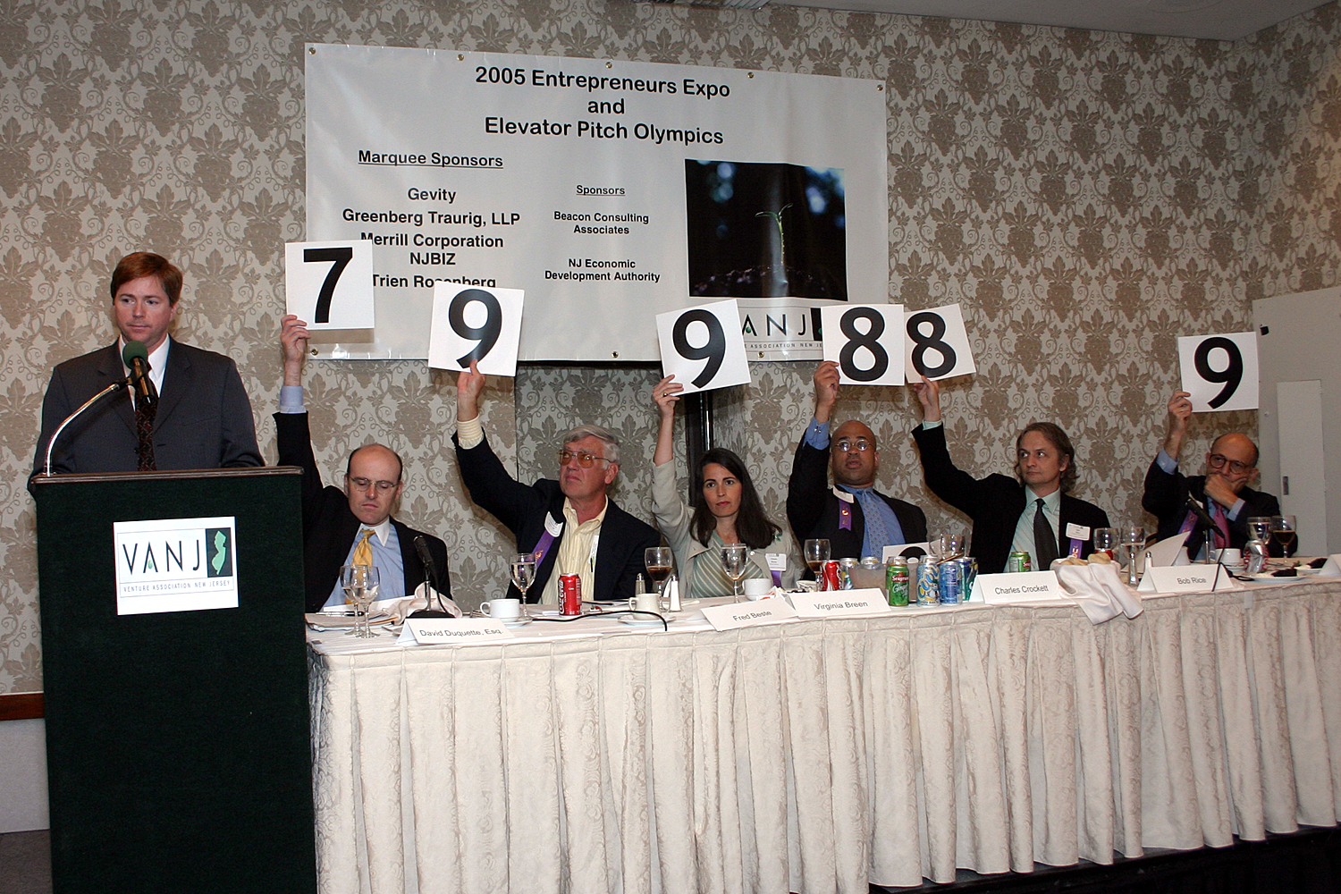

The panel is shown scoring the elevator pitch winner, Jay Fry, President & CEO, identiMetrics, Inc. (L-R) Moderator, David Duquette, Esq., Greenberg Traurig, LLP, Panelists Frederick J. Beste, III, President, Mid-Atlantic Venture Funds; Virginia Breen, Partner, Sienna Ventures; Charles Crockett, Partner, Ascend Venture Group LLC; Bob Rice, Angel Investor and Edwin Goodman, General Partner, Milestone Venture Partners

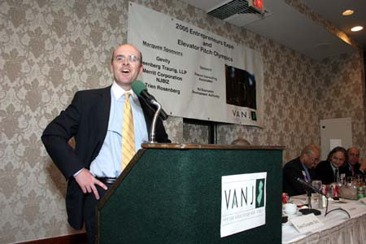
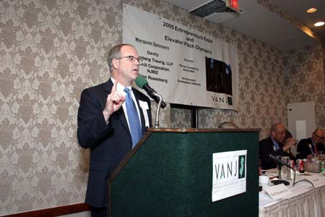

Marquee Sponsor, Peter Seidenstricker,
Regional Vice President, Gevity
Marquee Sponsor Panel Moderator, David Duquette, Esq., Greenberg Traurig, LLP

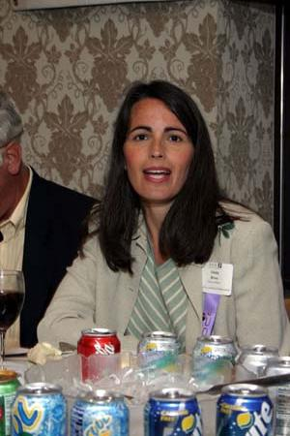
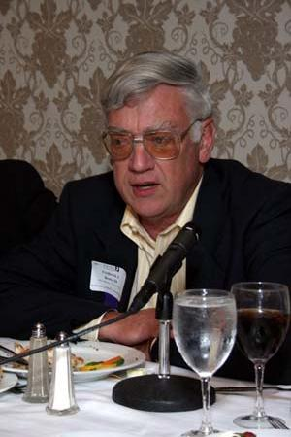

Investor Panelist, Edwin Goodman, General Partner, Milestone Venture Partners
Investor Panelist Virginia Breen, Partner, Sienna Ventures
Investor Panelist Frederick J. Beste, III
President, Mid-Atlantic Venture Funds
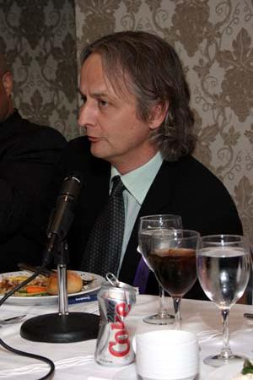
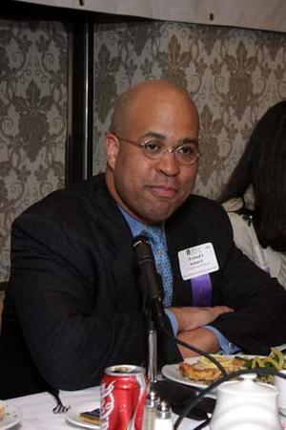

Angel Investor Panelist, Bob Rice
Investor Panelist Charles Crockett, Partner, Ascend Venture Group LLC

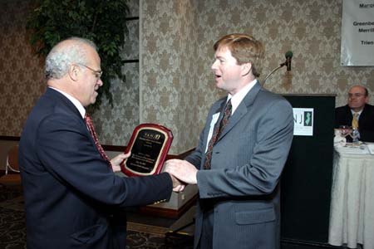
Investor Panelist, Edwin Goodman, General Partner, Milestone Venture Partners
VANJ President, Jay Trien presents the May 16, 2005 VANJ Expo’s Elevator Pitch Olympics award to Jay Fry, President & CEO of identiMetrics, Inc., of Malvern, PA
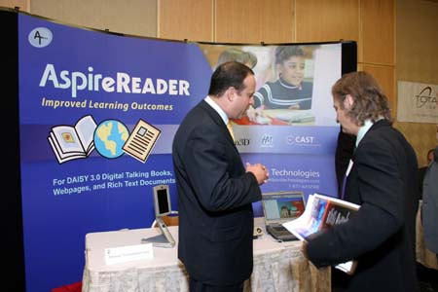
Richard Schatzberg, CEO, Aequus Technologies Corp. and angel investor Bob Rice
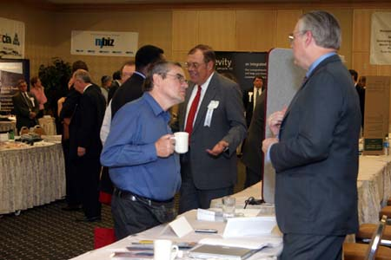
Angel Investor John Ason
speaks to an exhibitor
