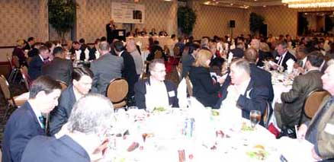
Luncheon attendees filled the room
Marquee Sponsor Gevity’s Exhibit
(L-R) Peter Seidenstricker, Vice President Northeast Region; William Noonan, Business Development Manager
Gustav Belo, Business Development Manager
Gregory Johnson, Business Development Manager
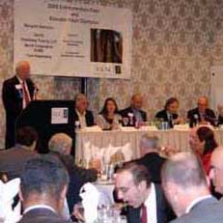
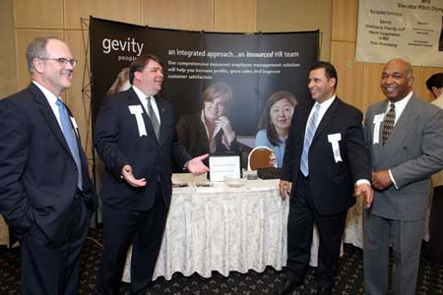
Jay Trien, President VANJ at podium greeting tables of attendees

