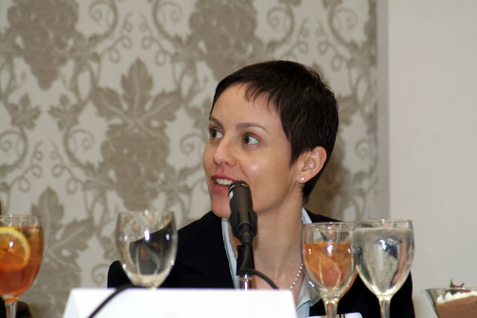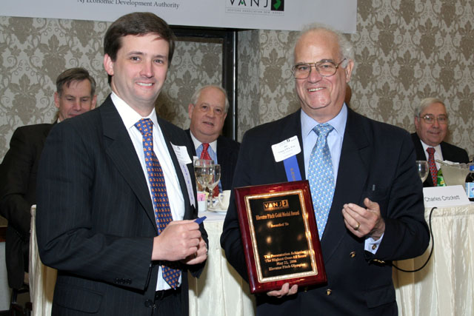
Investor Panelist, Hilary Gosher, Principal,
Insight Venture Partners
Elevator Pitch Winner, Whitney White, CEO,
Chromis Fiberoptics &
VANJ President & Trien Rosenberg, Sr. Partner, Jay Trien
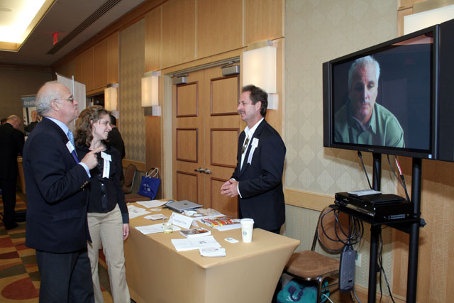
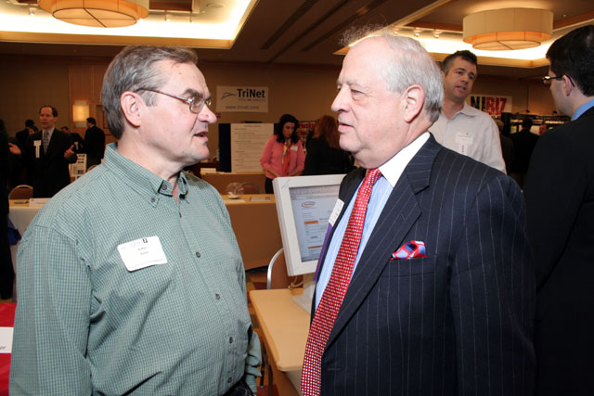

VANJ President & Trien Rosenberg, Sr. Partner, Jay Trien, with Ooana Trien, Associate Producer, Kaufman Films & Kevin Kaufman, President, Kaufman Films

Angel Investor, John Ason & Venture Capitalist, Warren Bagatelle, Managing Director,
Loeb Partners Corporation

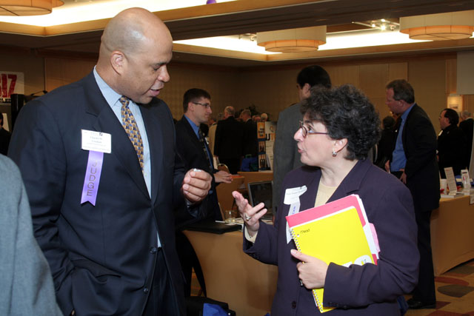

Investor Panelist, Charles Crockett, Co-Founder & Partner, Ascend Venture Group &
Anne Pauker Kreitzberg, President
Cognetics Corporation

