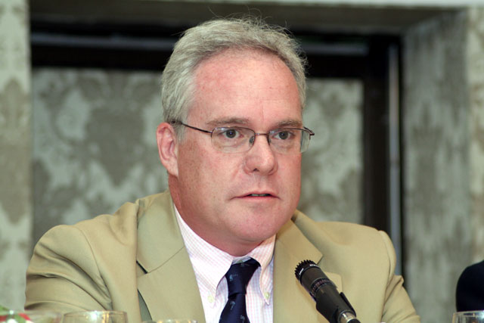
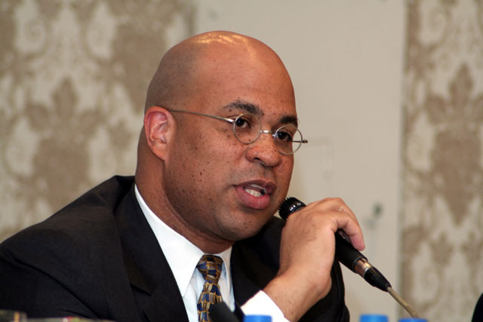
Panelist & Marquee Sponsor,
Michael E. Helmer, Esq., Partner,
Thacher Proffitt & Wood
Investor Panelist, Stephanie Hanbury- Brown,
Founding Angel Investor, Golden Seeds
Investor Panelist, Charles Crockett, Partner, Ascend Venture Group
