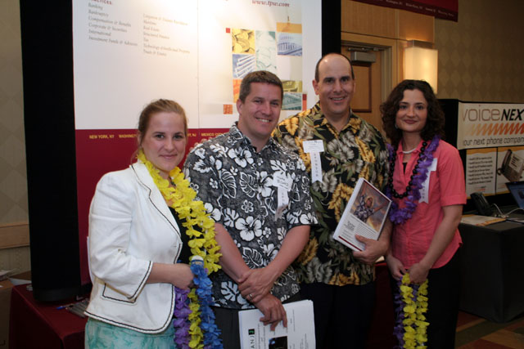
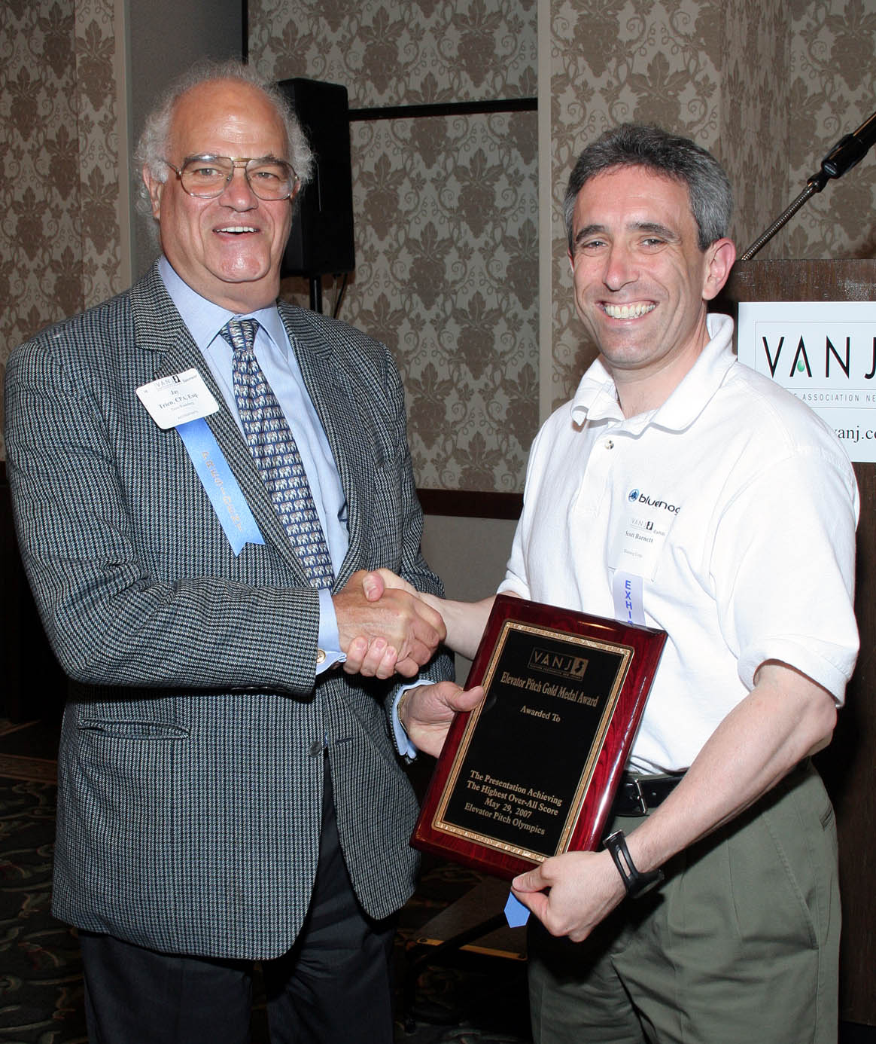
Jay Trien, CPA, Esq., President, VANJ & Senior Partner, Trien Rosenberg congratulates Elevator Pitch Olympics Winner, Scott Barnett, President, Bluenog Corp.
Marquee Sponsors from Thacher Proffitt & Wood, LLP
Melissa Kull, Mark Bisard, Esq., Lennie Nuara, Esq. and
Michelle Stinga
Note the leis around their necks. The partners explained that the leis illustrate their creative legal solutions for entrepreneurs. The Hawaiian paradise theme in their ad in the EXPO program book had the line "Work with us and your wildest dreams will come true." They distributed Hawaiian candies and leis to the attendees.
There's a photo of VANJ President, Jay Trien wearing his leis at the opening of the Elevator Pitch Olympics (see the first photos).

