2004 Business & Technology Showcase
and
Elevator Pitch Olympics
October 25, 2004
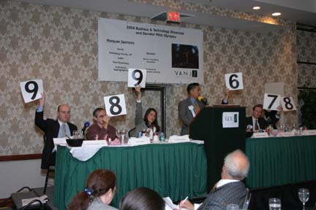
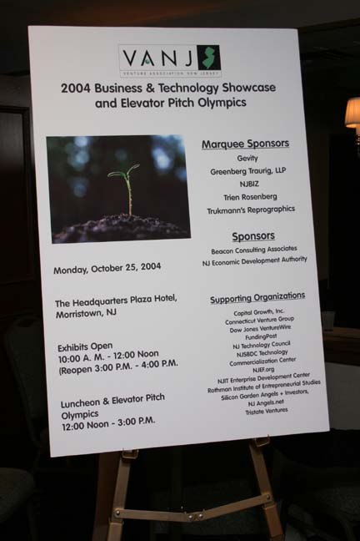
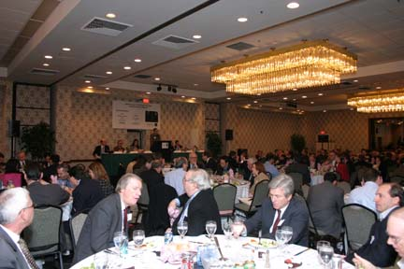
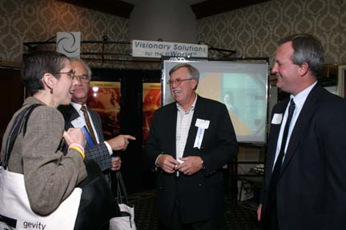
The panel is shown scoring the previous elevator pitch presenter, Tom Szaky, CEO of TerraCycle, Inc. who won the event. At the podium is Roger Aquinaldo, CEO of The M&A Advisor who is preparing to give his pitch.
(L-R) Moderator, David Duquette, Esq., Greenberg Traurig, LLP; Panelists - Angel Investor, John Ason; Blue Rock Capital Co-Founder & Partner, Virginia Bonker; TriState Venture Founder, Stephen Nagler; NY Angels, Inc., Executive Director, Chris Saxman; and Jumpstart New Jersey Angel Network Angel Investor, Tim Williams
Sold-Out Luncheon Crowd
The day opened with a morning workshop, Growing Your Business. The exhibits opened from 10 a.m. – 12 noon, the luncheon panel and elevator pitch Olympics were 12 noon - 3 p.m. and exhibits reopened from 3 p.m. – 4 p.m.
(L-R) NJEDA, CEO, Caren Franzini; VANJ President, Jay Trien; Exhibitor, n-tara CMO & Principal, Ralph O’Dell and Dillon Bitar & Luther’s J. Scott MacKay, Esq.,

