The panel is shown scoring the
elevator pitch winner,
David Dingott, President,
Sword Diagnostics

(L-R) Moderator, David Duquette, Esq.,
d’amour duquette and company llc
Panelists:
Dan Flatley, General Partner,
Masthead Venture Partners, LLC
Katherine O’Neill, Executive Director,
Jumpstart NJ Angel Network
Chris Saxman, Executive Director, NY Angels Marc Singer, General Partner, BEV Capital
October 24, 2005
Entrepreneurs Expo &
Elevator Pitch Olympics
View selected pitches at http://vanj.scribestudio.com

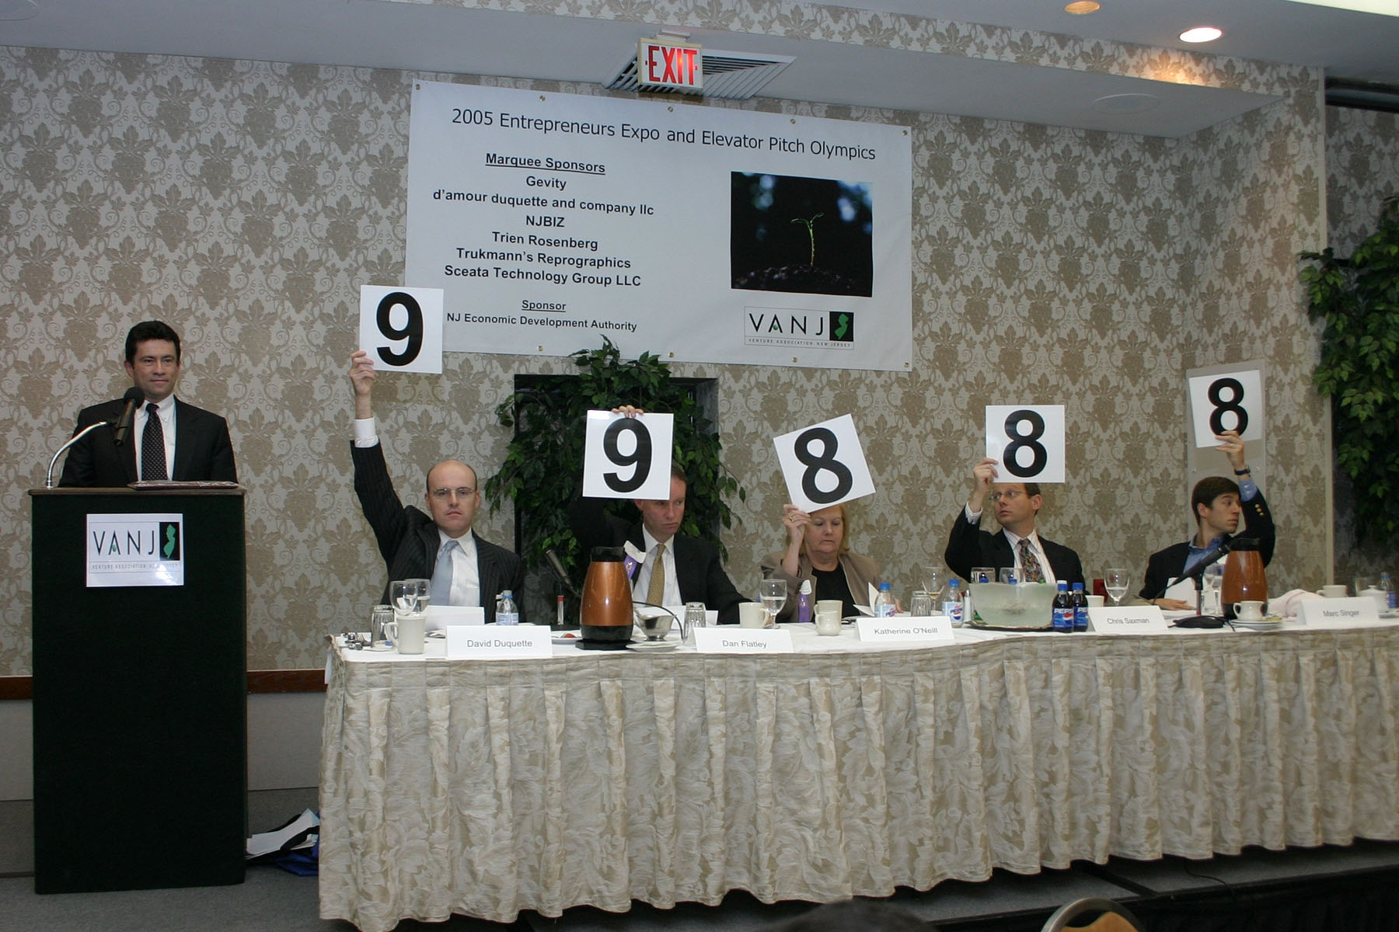
Jay Trien, President, VANJ & Sr. Partner,
Trien Rosenberg CPAs, welcomes attendees
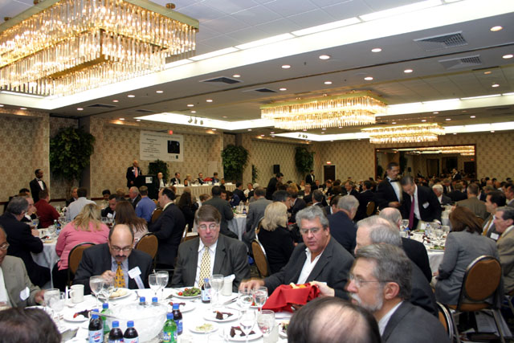
Sold out luncheon crowd
