
(Left) Bob Donaldson, President, Delta Planning & VANJ Board Member, speaks with exhibitor
Randy Taylor, StockPhotoFinder.
Representatives from Sound & Optics International speak to Panel Moderator, David Duquette, Esq., d’amour duquette and company llc (2nd from Right)
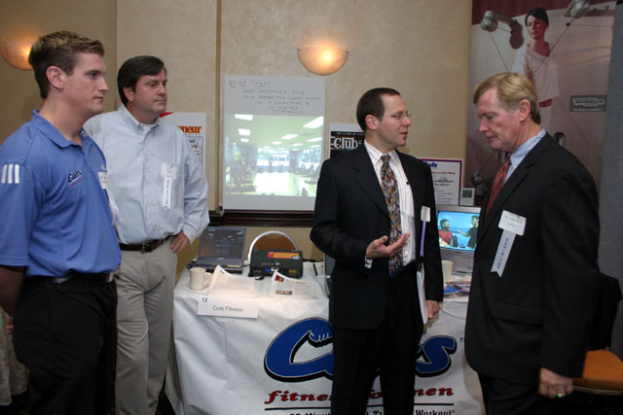
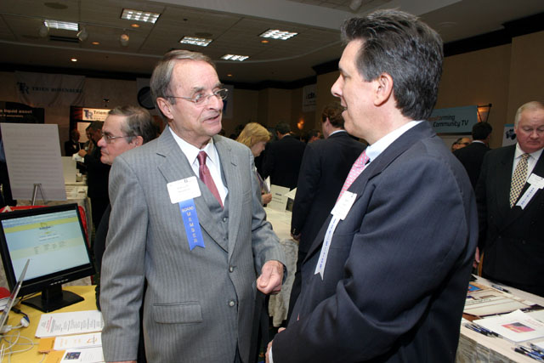
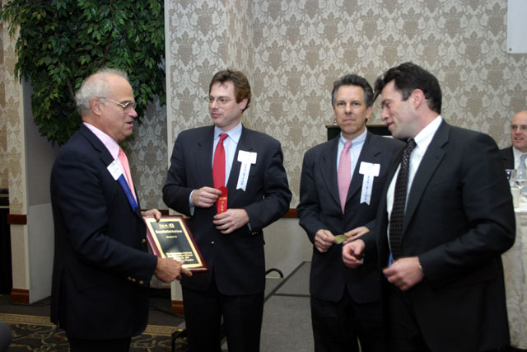
(Left to Right) Brian Healy, Director of Corporate Fitness, Cuts Fitness for Men; Thomas Crawford, Investor panelist, Chris Saxman and Dr. William J. Healy, VP Franchise Development

(Left) Investor panelist Katherine O’Neill with exhibitor Mary E. Repke, CEO, Coakley Business Class, LLC
(Left to Right) Jay Trien, President, VANJ presents awards. Paul Gilbert, CEO MedAvante (2nd Place), Randy Taylor, StockPhotoFinder (3rd Place) and
1st place winner David Dingott, Sword Diagnostics

