The venture capital panel is shown scoring the elevator pitch winner,
Miles Flamenbaum, President & CEO, SOMS Technologies
Panelists (left to right):
Virginia Breen, General Partner, Sienna Ventures
Steve Brotman, Managing Director, Greenhill SAVP Fund
Moderator, Leneord Nuara, Esq., Partner, Thacher Proffitt & Wood, LLP
Mat D. Carlson, Esq., Associate, Thacher Proffitt & Wood, LLP
Roger Krakoff, Venture Partner, Sigma Partners
Marc Singer, General Partner, BEV Capital

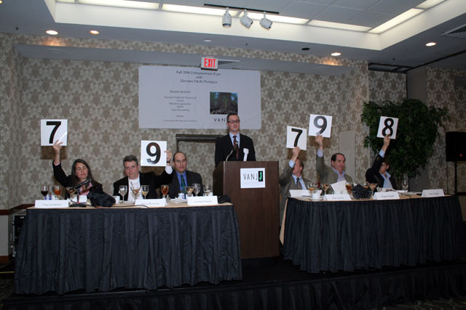
October 30, 2006
Entrepreneurs Expo & Elevator Pitch Olympics
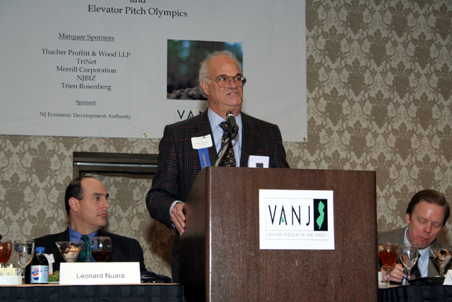
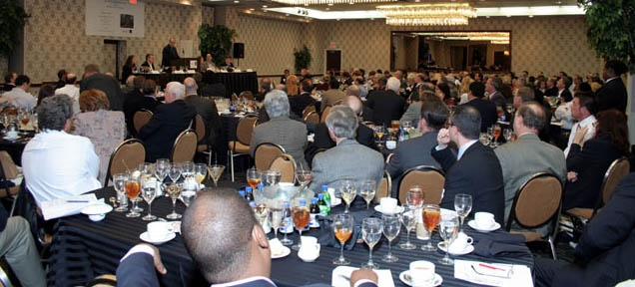
Sold out luncheon crowd
(L-R) Moderator, Leonard Nurara, Esq., Partner, Thatcher Proffitt & Wood, LLP, Jay Trien, President of VANJ & Sr. Partner, Trien Rosenberg, welcomes sold out luncheon, Mat Carlson, Esq., Associate, Thacher Proffitt & Wood, LLP

