Marquee Sponsor & Moderator, Leonard T. Nuara, Esq., Partner, Thacher, Proffitt & Wood, LLP
Investor Panelist, Virginia Breen, General Partner, Sienna Ventures
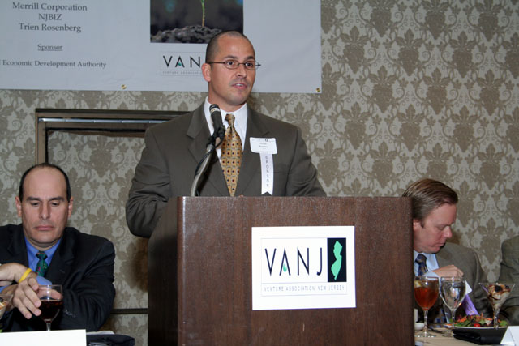
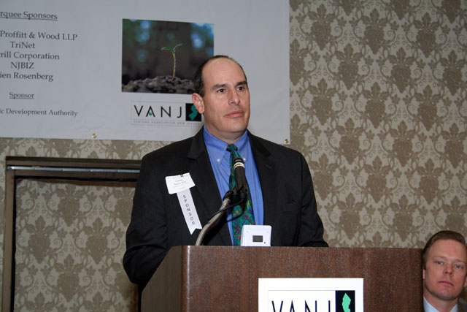
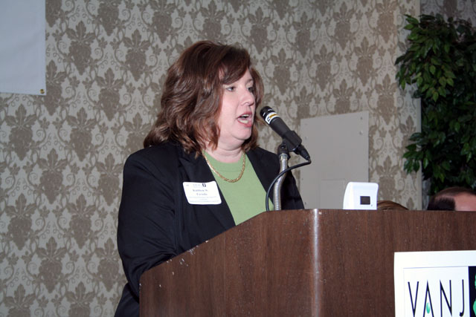
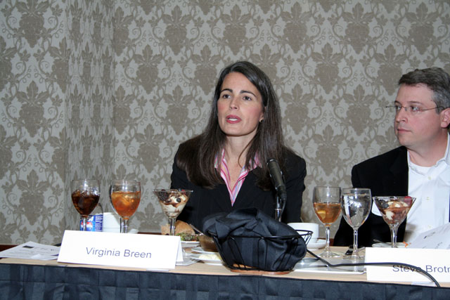
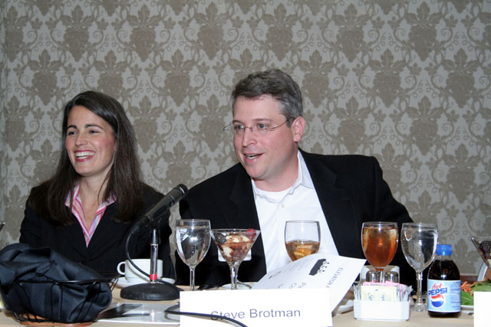
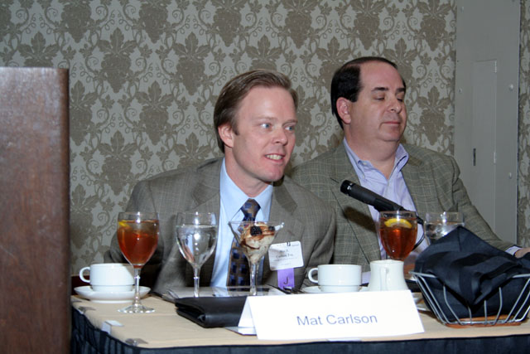
Marquee Sponsor, Joseph Bosotina, Regional Sales Consultant, TriNet Total HR Services
Sponsor, Kathleen Coviello, Program Manager-Science & Technology, NJ Economic Development Authority
Investor Panelist, Steve Brotman,
Managing Director & Founder,
Silicon Alley Venture Partners, LLC
Marquee Sponsor & Panelist, Mat Carlson, Esq., Associate, Thacher Proffitt & Wood, LLP and Roger Krakoff, Venture Partner, Sigma Partners

