Investor Marc Singer General Partner & Co-Founder,
BEV Capital and Miles Flamenbaum, President, SOMS Technologies
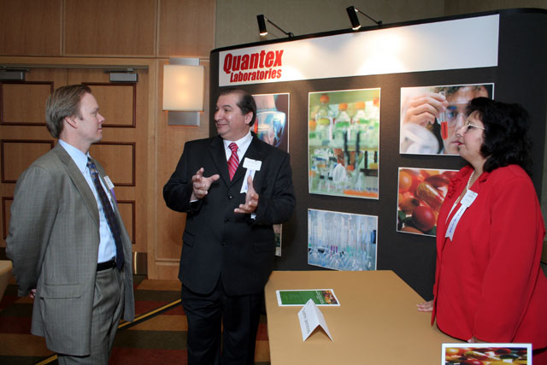
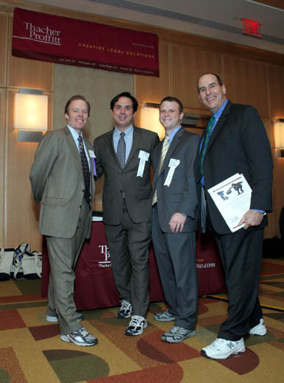
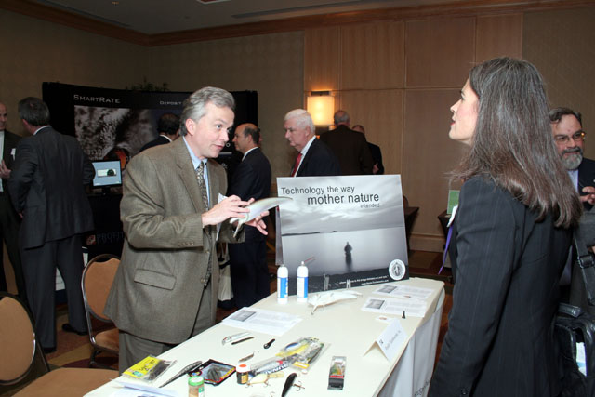
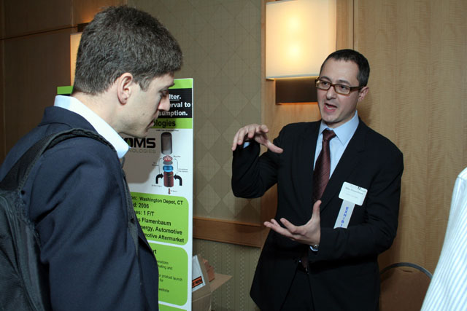
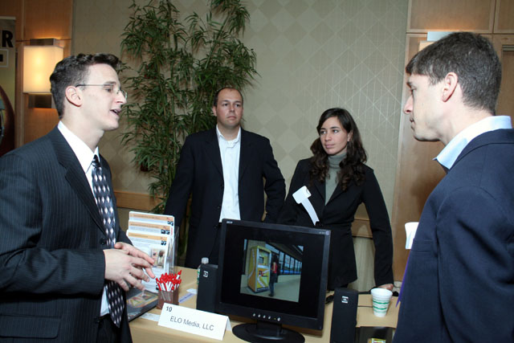
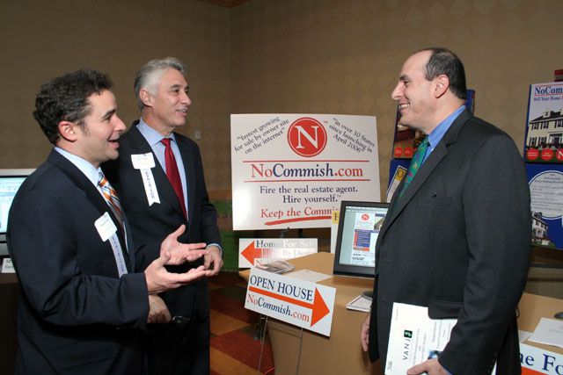
Gregory Mitchell, Chairman & Chief Science Officer, Mystic Tackleworks & Investor Virginia Breen, General Partner Sienna Ventures
L to R; Oren Hon, President ELO Media, Liron Polak, Chief Technical Officer, ELO Media, Ortit Polak, ELO Media and Investor Marc Singer, General Partner & Co-Founder
BEV Capital
Mat D. Carlson, Esq., Associate, Thacher Proffitt & Wood LLP, James Menoutis, Ph.D., President Quantex Laboratories and Angela Parisi-Menoutis, VP Laboratory Operations,
Quantex Laboratories
Rich Zeoli, CEO Marketing, NoCommish.com, Lawrence A. Casha, Esq., Casha & Casha and Moderator, Leonard T. Nuara, Esq., Partner, Thacher Proffitt & Wood, LLP
Marquee Sponsors from Thacher Proffitt & Wood, LLP
Mat D. Carlson, Esq., Thomas M. Laudise, Esq.,
Douglas E. Lippin, Esq. and Leonard T. Nuara, Esq.

