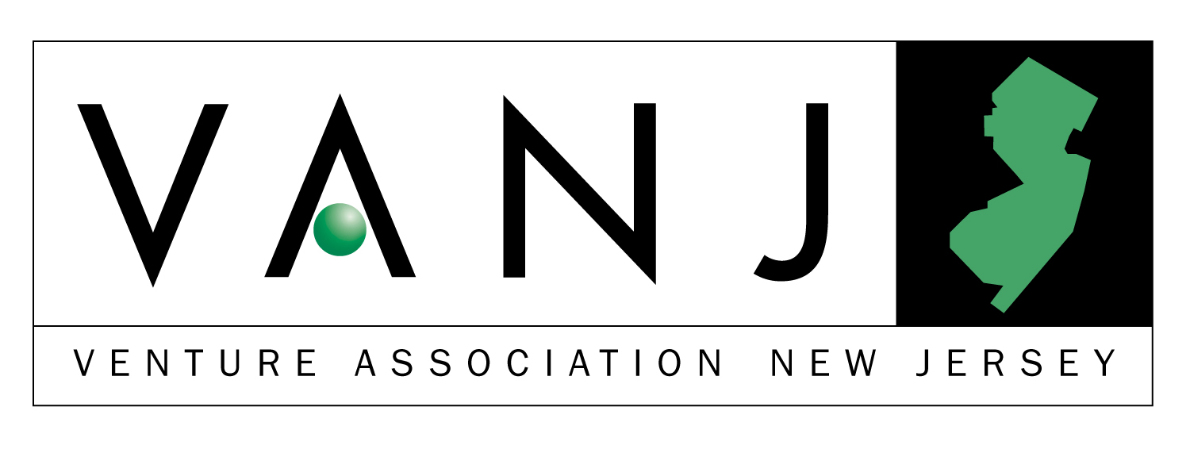
Second Annual Entrepreneurs Expo
Monday, May 13, 2002
The Westin Hotel, Morristown, NJ

Exhibits Open 10:00 AM through 4:00 PM

VANJ luncheon 11:30 AM through 2:00 PM

Entrepreneur Expo is an opportunity for emerging companies to display their innovative products or services to an audience of investors and supporters of New Jersey entrepreneurial activity. The Entrepreneur Expo features networking, exhibits, and exposure to representatives from a variety of funding sources including angel investors and early stage venture firms. At our luncheon, a panel of angel investors and early-stage venture capitalists will share their war stories of good and bad deals.

- Your opportunity to observe the latest entrepreneurial developments in this region.
- Network with venture capital firms, early stage startup companies, professional service providers, entrepreneurs, angel investors and corporate product planners.

Panel Moderator:
Bernard H. Tenenbaum, President of the Children’s Leisure Products Group (CLP) of The Jordan Company partners with talented entrepreneurial management of companies that make products that parents buy for children, including toys, sporting goods, housewares, candy, jewelry and health and beauty aids. Previously, he was Vice President of Corporate Development of Russ Berrie and Company responsible for the development and implementation of a diversification strategy through the acquisition and subsequent management of entrepreneurial companies that sell to the mass market. Acquisitions were purchased for $34.5 million and later sold to Hasbro for $166 million. Bernie was the founding Director of the George Rothman Institute of Entrepreneurial Studies at Fairleigh Dickinson University, and the first George Rothman Clinical Professor of Entrepreneurial Studies. He previously served as the Associate Director of the Sol C. Snider Entrepreneurial Center of The Wharton School of the University of Pennsylvania, founded the Wharton Small Business Development Center, the largest university-based consulting program for small companies in the United States and taught at The Wharton School for eight years prior to his Rothman appointment. Bernie is a graduate of Columbia College of Columbia University, with a B.A. in English, and did graduate work at Stanford University in Literature and Theatre. He received an MBA in Entrepreneurial Studies from The Wharton School in 1981. Bernie also is a partner or investor in a number of ventures, including a software company, a medical device manufacturer, and a real estate management company.

Panelists:

John Ason is an angel investor specializing in early stage pre-revenue companies. He has made twelve investments in the areas of e-commerce, 3D technology, internet publishing, smart labels, advertising and entertainment/media. John was at AT&T Bell Labs for over 25 years, first involved in software and technology development, then in marketing and business management of large software projects. He is a graduate of the Illinois Institute of Technology.

Warren Bagatelle is Managing Director, Loeb Partners Corporation since 1988. Responsibilities include all elements of corporate finance. Specific activities cover identifying, financing and monitoring investments in small and medium size companies; providing advisory services on mergers, acquisitions, divestitures and restrucurings; and advising on, managing and co-managing public offerings. Loeb Partners is a small. full service investment banking firm based in New York City.

Jim Gunton has been investing in or working with high technology companies for nearly fifteen years. Since 1994 he has lead the Edison Venture Fund’s investment efforts in New Jersey, and in 2001 was named a general partner for the NJTC Venture Fund, an early stage venture capital fund focused on financing New Jersey companies. Jim holds degrees from Stanford University and Duke University, where he was the winner of the “Class of 1987” scholarship.

Our Marquee Sponsors

Trien Rosenberg





Bryan Finkel has spent over 15 years in operating and financial advisory roles within the information technology industry. His areas of expertise include Internet-based products and services, software, and electronic technologies. Prior to forming Advanta Growth Capital he was managing director with Technology Venture Management, a firm he formed to provide strategic, operational, and financial advisory services to early stage technology companies. His clients included Yoyodyne Entertainment (acquired by Yahoo! Inc.); Sedona (NASDAQ: SDNA), a developer of software for Geospatial Information Systems; Sensar (NASDAQ: SCII), a manufacturer of scientific instruments and sensors; and other Information Technology companies. Mr. Finkel holds a Master of Business Administration degree from the Stanford Graduate School of Business, and Master and Bachelor of Science Degrees in Electrical Engineering from MIT, where he was a member of Eta Kappa Nu, an honorary electrical engineering fraternity. He is Chairman of the Board of Directors of the MIT Enterprise Forum of New York City, and has authored numerous articles about information technology and the business trends that affect the IT marketplace.

Ronald R. Hahn is a Partner of Early Stage Enterprises, LP (ESE). ESE is a venture capital fund organized to invest in and provide business development assistance to seed and early stage companies. During his thirty-year career, Ron has worked with companies in a number of different industries. He currently serves on the boards of five ESE portfolio companies. His experience also includes organizing public offerings, private placements, and acquisitions. In addition, he has started a successful business, operated as a crisis manager and consulted to numerous organizations. Earlier in his career, he founded Princeton-Montrose Partners, LP, a venture capital fund specializing in life science technology. Before founding ESE, he was a Vice President and General Partner of Patricof & Co. (now Apax Partners), a New York based venture capital organization. Ron received his BA degree from Occidental College, and his MBA degree from the Anderson School of Management, University of California, Los Angeles.

Upcoming Meeting: Tuesday, June 18, 2002
June 18, 2002 – Jeff Parness, Founder & CEO StartupSuccess 2002, Co-Founder, VenturiFX, QOptics and QWireless
“15 Winning Finance Strategies Straight From the Trenches:
An Entrepreneur’s Perspective on How To Actually Raise Early Stage Capital in 2002!”

July 16, 2002

Jim Gunton - General Partner – NJTC Venture Fund

The luncheon portion of our Expo is limited to 300 attendees. To ensure your space, please preregister. Send your check payable to VANJ ($25 members, $75 nonmembers) along with this form to be received no later than May 8th to: VANJ, Box 1982, Morristown, NJ 07962-1982. Door registration, if available is $100. For further information call 973-267-4200, Ext. 193 or email clara@vanj.com.
NAME : TITLE:

COMPANY:

ADDRESS:

PHONE: FAX: EMAIL:

(Check One) Entrepreneur ____ Investor/Lender ____ Consultant ____ Seeking New Job ____

Yes, I will attend the May 13th Luncheon Program ($75 Non Members, $25 Members)

