Third Annual Entrepreneurs Expo
Monday, May 19, 2003
The Westin Hotel, Morristown, NJ

Exhibits Open 10:00 AM through 1:00 PM

VANJ luncheon 1:00 PM through 3:00 PM
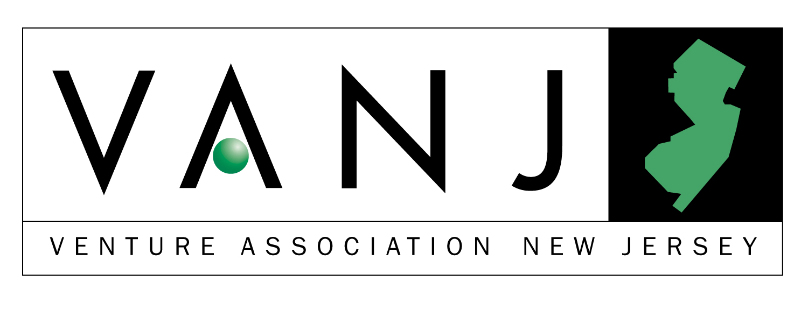

Marquee Sponsors



Trien Rosenberg




Beacon Consulting Associates
Sponsors:




Entrepreneur Expo is an opportunity for emerging companies to display their innovative products or services to an audience of investors and supporters of New Jersey entrepreneurial activity. The Entrepreneur Expo features networking, exhibits, and exposure to representatives from a variety of funding sources including angel investors and early stage venture firms. Hear a panel of early stage venture capitalists offer advice that will assist you to raise capital in “the worst VC market in the history of the world”.

- Your opportunity to observe the latest entrepreneurial developments in this region.
- Network with venture capital firms, early stage startup companies, professional service providers, entrepreneurs, angel investors and corporate product planners.

Panel Moderator:
Bernard H. Tenenbaum, Past President of the Children’s Leisure Products Group (CLP) of The Jordan Company partners with talented entrepreneurial management of companies that make products that parents buy for children, including toys, sporting goods, housewares, candy, jewelry and health and beauty aids. Previously, he was Vice President of Corporate Development of Russ Berrie and Company responsible for the development and implementation of a diversification strategy through the acquisition and subsequent management of entrepreneurial companies that sell to the mass market. Acquisitions were purchased for $34.5 million and later sold to Hasbro for $166 million. Bernie was the founding Director of the George Rothman Institute of Entrepreneurial Studies at Fairleigh Dickinson University, and the first George Rothman Clinical Professor of Entrepreneurial Studies. He previously served as the Associate Director of the Sol C. Snider Entrepreneurial Center of The Wharton School of the University of Pennsylvania, founded the Wharton Small Business Development Center, the largest university-based consulting program for small companies in the United States and taught at The Wharton School for eight years prior to his Rothman appointment. Bernie is a graduate of Columbia College of Columbia University, with a B.A. in English, and did graduate work at Stanford University in Literature and Theatre. He received an MBA in Entrepreneurial Studies from The Wharton School in 1981. Bernie also is a partner or investor in a number of ventures, including a software company, a medical device manufacturer, and a real estate management company.

John Ason is an angel investor specializing in early stage pre-revenue companies. He has made thirteen investments in the areas of e-commerce, 3D technology, internet publishing, smart labels, advertising and entertainment/media. John was at AT&T Bell Labs for over 25 years, first involved in software and technology development, then in marketing and business management of large software projects. He is a graduate of the Illinois Institute of Technology.

Warren Bagatelle is Managing Director, Loeb Partners Corporation since 1988. Responsibilities include all elements of corporate finance. Specific activities cover identifying, financing and monitoring investments in small and medium size companies; providing advisory services on mergers, acquisitions, divestitures and restrucurings; and advising on, managing and co-managing public offerings. Loeb Partners is a small. full service investment banking firm based in New York City.

Virginia Bonker is a Partner and co-founder of Blue Rock Capital, a private equity fund focused on investing in early-stage information technology and service businesses in the eastern US. Ginnie is also a Partner of the Sienna Genesis Fund which focuses on investing in early and expansion-stage private companies in consumer products, information technology and business services. She currently serves on the Boards of Integrated Chipware, Ranch Networks, LockStar, and previously, Edison Schools (Nasdaq: EDSN). Ginnie also joined the Board of CMGI, Inc. (Nasdaq: CMGI) in April 2001. Ginnie was formerly a Vice President with the Sprout Group, the venture capital affiliate of Donaldson, Lufkin & Jenrette (now Credit Suisse First Boston). She was also an Investment Analyst with DLJ’s Investment Banking Group and, prior to that, worked as a Systems Analyst and Product Marketing Engineer at Hewlett-Packard. Ginnie received her MBA with Highest Honors from Columbia University and her undergraduate degree in Computer Science with Electrical Engineering from Harvard College. Ginnie was also an International Rotary Scholar, studying philosophy in Southeast Asia.

Bryan Finkel has spent over 15 years in operating and financial advisory roles within the information technology industry. His areas of expertise include Internet-based products and services, software, and electronic technologies. Prior to forming Advanta Growth Capital he was managing director with Technology Venture Management, a firm he formed to provide strategic, operational, and financial advisory services to early stage technology companies. His clients included Yoyodyne Entertainment (acquired by Yahoo! Inc.); Sedona (NASDAQ: SDNA), a developer of software for Geospatial Information Systems; Sensar (NASDAQ: SCII), a manufacturer of scientific instruments and sensors; and other Information Technology companies. Mr. Finkel holds a Master of Business Administration degree from the Stanford Graduate School of Business, and Master and Bachelor of Science Degrees in Electrical Engineering from MIT, where he was a member of Eta Kappa Nu, an honorary electrical engineering fraternity. He is Chairman of the Board of Directors of the MIT Enterprise Forum of New York City, and has authored numerous articles about information technology and the business trends that affect the IT marketplace.

Jim Gunton has been building high technology companies for fifteen years starting in Silicon Valley as a Product Line Manager at Oracle Corporation. Since 1994 he has lead the Edison Venture Fund’s investment efforts in New Jersey, and in 2001 was named a general partner for the NJTC Venture Fund, an $80 million early stage venture capital fund focused on financing New Jersey companies. Jim holds degrees from Stanford University and Duke University, where he was the winner of the “Class of 1987” scholarship.

View pictures from last year’s event - www.vanj.com

The luncheon portion of our Expo is limited to 300 attendees. To ensure your space, please preregister. Send your check payable to VANJ ($25 members, $75 nonmembers) along with this form to be received no later than May 8th to: VANJ, Box 1982, Morristown, NJ 07962-1982. Door registration, if available is $100. For further information call 973-267-4200, Ext. 193 or email clara@vanj.com.
NAME : TITLE:

COMPANY:

ADDRESS:

PHONE: FAX: EMAIL:

(Check One) Entrepreneur ____ Investor/Lender ____ Consultant ____ Seeking New Job ____

Yes, I will attend the May 19th Luncheon Program ($75 Non Members, $25 Members)

