Fourth Annual Entrepreneurs Expo
Monday, May 17, 2004
The Westin Hotel, Morristown, NJ

Exhibits Open 10:00 AM through 1:00 PM (Reopen 3-4 PM)

VANJ luncheon 1:00 PM through 3:00 PM
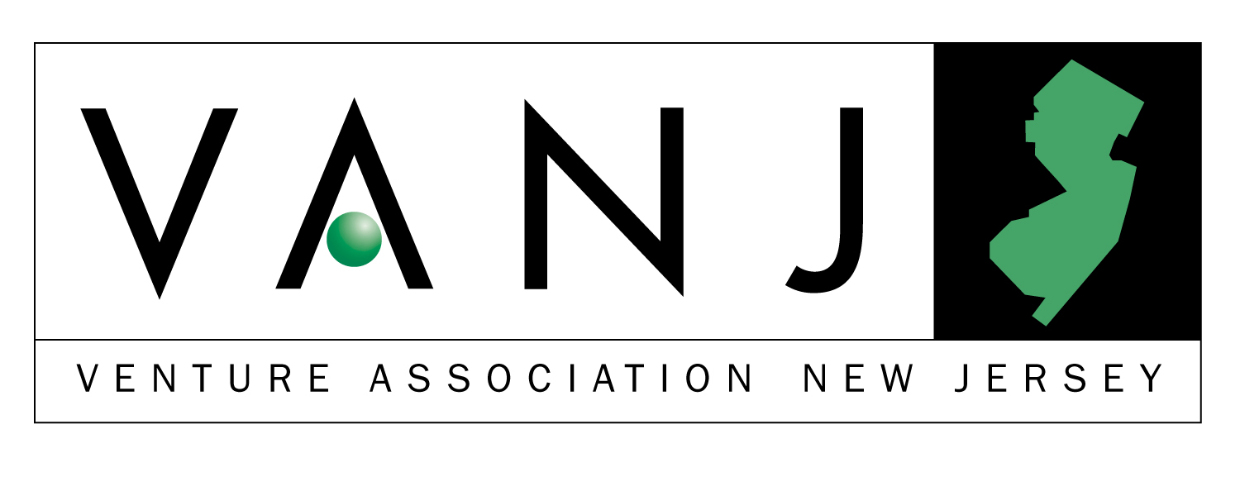
www.vanj.com


Marquee Sponsors
Commerce Insurance Services Hale & Dorr LLP Trien Rosenberg

Sponsors
Beacon Consulting Associates NJBIZ NJ Economic Development Authority
Abracadabra Color Copy Center Cartridge World of New Jersey

Entrepreneur Expo is an opportunity for early-stage and emerging companies to display their products or services to an audience of venture capital firms and angel investors and supporters of New Jersey entrepreneurial activity. The Entrepreneur Expo features networking, exhibits, and exposure to representatives from a variety of funding sources and a panel of early stage angel investors offer advice on raising capital.

Panel Moderator:
Bernard H. Tenenbaum, Former President of the Children’s Leisure Products Group (CLP) of The Jordan Company partners with talented entrepreneurial management of companies that make products that parents buy for children, including toys, sporting goods, housewares, candy, jewelry and health and beauty aids. Earlier this year, CLP sold Vivid Imaginations, the largest independent toy company in the UK, for a 7x multiple of the original investment. Vivid’s volume exceeded $130 million at the time of the sale. Previously, he was Vice President of Corporate Development of Russ Berrie and Company responsible for the development and implementation of a diversification strategy through the acquisition and subsequent management of entrepreneurial companies that sell to the mass market. Acquisitions were purchased for $34.5 million and later sold to Hasbro for $166 million. Bernie was the founding Director of the George Rothman Institute of Entrepreneurial Studies at Fairleigh Dickinson University, and the first George Rothman Clinical Professor of Entrepreneurial Studies. He previously served as the Associate Director of the Sol C. Snider Entrepreneurial Center of The Wharton School of the University of Pennsylvania, founded the Wharton Small Business Development Center, the largest university-based consulting program for small companies in the United States and taught at The Wharton School for eight years prior to his Rothman appointment. Bernie is a graduate of Columbia College of Columbia University, with a B.A. in English, and did graduate work at Stanford University in Literature and Theatre. He received an MBA in Entrepreneurial Studies from The Wharton School in 1981. Bernie also is a partner or investor in a number of ventures, including a software company, a medical device manufacturer, and a real estate management company.

John Ason is an angel investor specializing in early stage pre-revenue companies. He has made twelve investments in the areas of e-commerce, 3D technology, internet publishing, smart labels, advertising and entertainment/media. John was at AT&T Bell Labs for over 25 years, first involved in software and technology development, then in marketing and business management of large software projects. He is a graduate of the Illinois Institute of Technology. He is a guest lecturer at the Rothman Institute of Entrepreneurial Studies at Fairleigh Dickinson and at the Wharton School of the University of Pennsylvania.

Alan Patricof - is Vice Chairman of Apax Partners, Inc. Prior to founding Patricof & Co. in 1969, he was assistant to the chairman of Northwest Industries in charge of acquisitions and pension fund management. From 1960 to 1968 he was assistant vice president and subsequently vice president of Central National Corp., a private, family investment management organization. While at Central National, he became a founder and chairman of the board of New York magazine, which later acquired The Village Voice and started New West Magazine. Also while at Central National, he participated in the founding of Datascope Corporation and LIN Broadcasting Corporation.

During the past 30 years, he has participated in the financing and development of a large number of both public and private companies, many of which he still serves as a member of the board of directors. Companies that the firm has been involved in at the initial stages are Apple Computer, America Online, Cadence Systems, Office Depot and FORE Systems. Alan holds a BS in finance from Ohio State University and an MBA.

Jeanne Sullivan - Jeanne has had an email address since 1980. She is proud of being part of the technology revolution over the last 20 years and working with some of the world's greatest high tech companies. Jeanne likes to say, "I have participated in some of the most successful companies of our times, seen great CEO's and teams in action and learned how to and how not to build a great company…" She represents StarVest on the boards of Tibersoft, BlueStreak, Vcommerce and supports StarVest's efforts with Journee and Cohesiant.

Prior to StarVest, Jeanne's 27-year business career includes 20 years in the information technology field and seven years in the venture capital business as a Managing Director for Olivetti Ventures and 4C Ventures, captive funds of Ing. C. Olivetti & C., S.p.A. These U.S.-based funds invested in 40 early and growth-stage information technology companies. From 1981 to 1990, Jeanne was with AT&T and was the Product Director for a Bell Laboratories internal venture business unit. From 1971 to 1978, she was with Bozell Worldwide, in business marketing and production director roles.

Bringing a full grasp of the issues facing companies today, Jeanne contributes in the areas of marketing, channel development, product direction and strategic participation in the exit strategies of technology companies. She helped build the NYNMA Angel Investors Program and served as its Chair of the selection program. Jeanne is also a member of Women in New Media, the MIT Enterprise Forum, and NY Cares. Golf, travel, politics, outdoor sports, all sports--watching and participating with her family--are her passion when not reading technology journals and business plans. She is a frequent guest lecturer on the subject of investing in technology companies. She holds a BS from the University of Illinois and a JD from Creighton University.

A. Wayne Tamarelli PhD, MBA, is President, AWT Private Investments. Wayne has 37 years experience in entrepreneurship, general management, new ventures, mergers and acquisitions, advanced materials, environmental protection products, energy conservation technologies, specialty chemicals, technology transfer, angel investing, and other business and technological areas. His primary business activity is as a value-added angel investor in early stage technology businesses in the New Jersey and San Francisco Bay areas, making both active and passive investments. He serves on a number of boards of directors and advisory boards.

In 1983 he purchased Dock Resins Corporation in a leveraged buyout and successfully grew its revenues and profits as Chairman, CEO and sole owner. In 1997 he sold the company at a substantial profit and remained CEO until 2000.
He was with Engelhard Corporation from 1970 to 1983 as Senior Vice President where he managed $billion+ groups of worldwide businesses and also had senior management responsibility for corporate strategic planning and corporate R&D.
He was an R&D manager at Exxon from 1966 to 1970. Earlier Dr. Tamarelli served as a captain in the U.S. Army and an engineering professor at Carnegie-Mellon University. He has BS, MS, and PhD degrees in engineering from Carnegie-Mellon University and an MBA in marketing and international business from New York University.

View pictures from last year’s event - www.vanj.com

The luncheon portion of our Expo is limited to 300 attendees. To ensure your space, please preregister. Send your check payable to VANJ ($45 members, $75 nonmembers) along with this form to be received no later than May 7th to: VANJ, Box 1982, Morristown, NJ 07962-1982. Door registration, if available is $100. For further information call 973-267-4200, Ext. 193 or email clara@vanj.com.
NAME : TITLE:
COMPANY:
ADDRESS:
PHONE: FAX: EMAIL:

(Check One) Entrepreneur ____ Investor/Lender ____ Consultant ____ Seeking New Job ____

Yes, I will attend the May 17th Luncheon Program ($75 Non Members, $45 Members)

