VANJ’S 2005 Entrepreneurs Expo

Elevator Pitch Olympics

Monday, October 24, 2005
The Headquarters Plaza Hotel, Three Headquarters Plaza (Speedwell Avenue), Morristown, NJ

Take advantage of this opportunity to network with venture capital firms, angel investors, early stage startup companies, professional service providers, entrepreneurs and corporate licensing and strategic partnering executives.

Learn more about investing, corporate partnering, and technology licensing and acquisition opportunities.

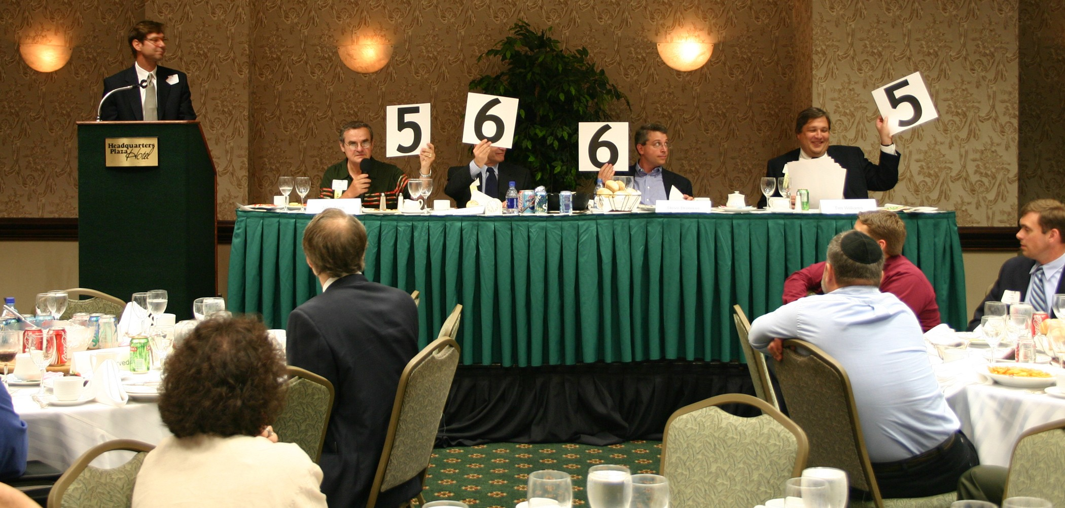

The day begins at 8:30 AM with a workshop on “Launching & Growing A Business In New Jersey.” At 10:00 AM the exhibit hall opens and as many as 40 companies that are seeking capital showcase their companies. At noon the luncheon program begins with our investor panel that focuses on the best ways for early stage companies to attract growth capital from angel or venture capital investors. The day’s luncheon program ends with the Elevator Pitch Olympics from 1:30 – 3:00 PM. The exhibits will open up again at 3:00 PM – 4:00 PM for further networking.

An elevator pitch is a short presentation made by an entrepreneur raising money for a venture. The term describes a pitch that’s short enough that it could be given during an elevator ride when the entrepreneur has the only chance to talk with a potential investor. Just as in the real Olympics, the investor judges hold up their scores and give points ranging from one to ten in the categories of quality of presentation and business fundability.

Marquee Sponsors

Gevity
d'amour duquette and
company llc

NJBIZ
Sceata Technology Group LLC

Trien Rosenberg
Trukmann’s Reprographics

Sponsors
NJ Economic Development Authority

Supporting Organizations
Connecticut Venture Group
Foundations Business
Development Group
FundingPost
NJIT Enterprise Development Center
NJ Technology Council
NJEF
Pennsylvania Angel Network
Silicon Garden Angels +
Investors, NJ Angels.net
Rothman Institute of Entrepreneurial Studies
TriState Ventures

Investors
Efficiently invest your time to visit entrepreneur exhibits and hear the elevator pitches at one event.

Entrepreneurs
Network with Investors and learn from other entrepreneurs exhibits and elevator pitches.

Panelists & Elevator Pitch Olympic Judges

Moderator – David Duquette, Esq., principal, d'amour duquette and company llc
Marc Singer, General Partner, BEV Capital
Dan Flatley, General Partner, Masthead Venture Partners, LLC
Katherine O’Neill, Executive Director, Jumpstart NJ Angel Network
Chris Saxman, Executive Director, NY Angels

Monday, October 24, 2005
The Headquarters Plaza Hotel, Morristown, NJ

Westin
9:00 am - 5:00 pm
Westin Hotel, 2 Whippany Road, Morristown, NJ

Morning Workshop – Launching & Growing 8:30 AM – 11:00 AM
A Business

Company Exhibits 10:00 AM - 12:00 PM
3:00 PM - 4:00 PM

Luncheon Program & 12:00 PM - 3:00 PM

Elevator Pitch Olympics

ATTENDEE REGISTRATION

Morning Workshop: This workshop, limited to 50 attendees, will take participants through the business development process and discuss sources of assistance available to New Jersey entrepreneurs. The fee is $25, register using the form below.

Luncheon Program: Register by mail using the form below. The cost of the luncheon program is $75.00 (VANJ Members $50.00). Given the large turnout expected for the luncheon we may not be able to accept door registrations and reservations MUST be prepaid. Register early — last year’s luncheon was oversubscribed.

View Company Exhibits: FREE 10:00 AM – 12:00 Noon (Pre-registration Not Required)

For luncheon registration and or workshop registration please complete this form (or attach your business card), attach your check to VANJ for the proper amount and mail to VANJ, Box 1982, Morristown, NJ 07962-1982. Telephone, fax or e-mail reservations are possible, but your registration and payment for the luncheon must be received within 7 business days before. Please call Clara Stricchiola at 973-631-5680. or fax your registration to 973-984-9634 or email clara@vanj.com. (An attendance roster will be distributed.) Visit www.vanj.com to view pictures from previous events.

2005 Entrepreneurs Expo & Elevator Pitch Olympics Registration
($75 non-members; $50 members)
Monday, October 24, 2005
(Fill out this form or simply attach your business card)

I will attend the Luncheon Program ($75 non-members; $50 members)
(Please note, pitches are given by exhibitors only)
I will attend the Morning Workshop ($25) (Limited to 50 attendees)

Name & Title:

Company:

Address:

City, State, Zip:
Phone: Fax: Email:
Luncheon Fee: $50 VANJ Members $75 Non-Members

(Circle One) Entrepreneur Investor/Lender Consultant Seeking New Job

Please make sure you check below which program(s) you are attending.

