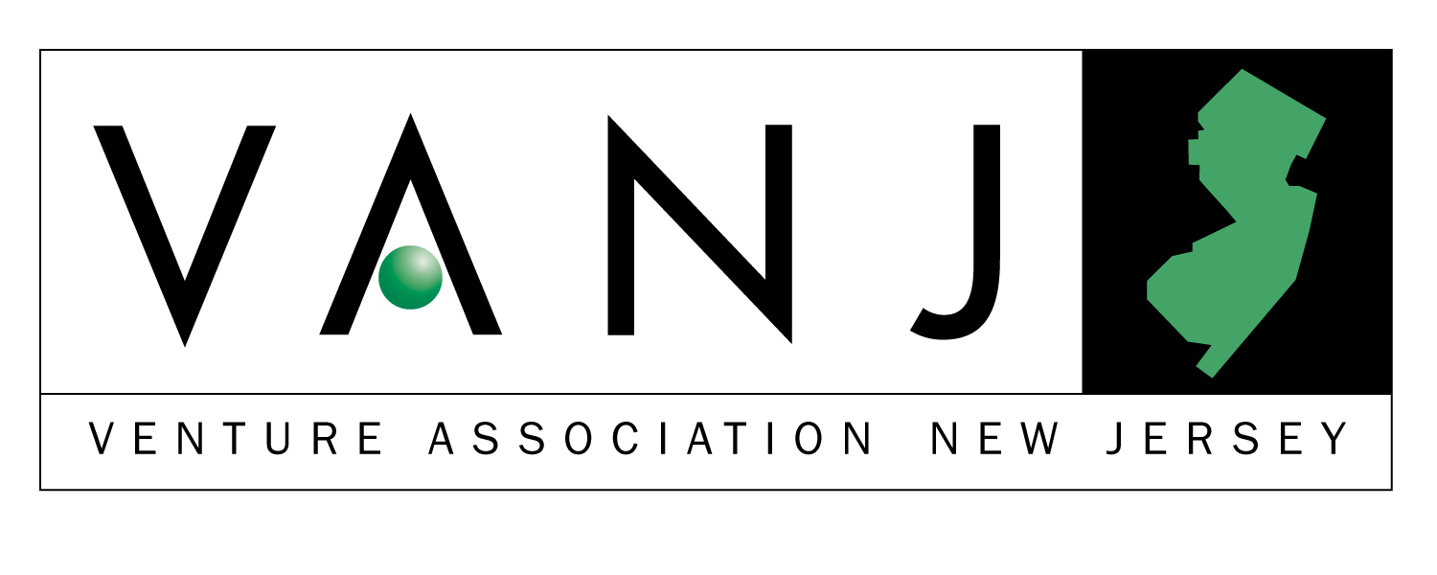

DATE: Tuesday, January 15, 2002
SPEAKER: Daniel Raynor, Founder & General Partner, The Argentum Group – www.argentumgroup.com
TIME: Registration, 11:30 a.m.; Meeting, 12:00 noon - 2:00 p.m.
PLACE: The Westin (Formerly The Governor Morris Hotel), Morristown, NJ

Directions Only - Call Hotel 973-539-7300

Surviving a Follow-On Round of Venture Funding in a Punitive Environment
Companies seeking second and third round venture funding are facing many serious challenges in today’s difficult capital raising environment. Not only must they make a compelling business case to attract investment interest in a tight market, but they must also resolve many confounding issues involving their existing capital structure and the diverging interests of various constituencies – i.e., management, old investors, new investors, common stockholders.

Young companies and their advisors must understand the realities of the marketplace and adopt financing and negotiating strategies that offer the best chance of surviving a very difficult process. Even more importantly, companies often need to recalibrate their operating strategies in order to be in line with their ability to access capital.

Daniel Raynor, a founder and general partner of the private equity firm The Argentum Group, will discuss the many challenges facing young companies as they seek to obtain follow-on rounds of venture capital. He will discuss his firm’s approach to later-stage investing with respect to both existing portfolio companies and new opportunities. He will focus on the important terms and conditions of a follow-on financing and strategies designed to resolve potential issues among the different constituencies.

After beginning his career as an investment banker, Mr. Raynor founded The Argentum Group in 1987 with his partner, Walter Barandiaran. Argentum currently serves as a general partner of five investment partnerships with total capital of approximately $400 million, of which about $160 million is still available for future investments. Since its founding, Argentum has made over 100 investments in a broad range of industries including business/outsourcing services, technology, and healthcare. The firm has invested in many companies that have emerged as leaders in their respective industries including Omnipoint Corp. (wireless PCS), USA Waste/Waste Management (solid waste), White Cap Industries (specialty distribution), NuCo2 (specialty chemicals), Security Dynamics (network security) and Automated Healthcare (healthcare IT/acquired by McKesson), and FYI (document management).

Mr. Raynor serves on the board of directors of Comforce Corporation (ASE:CFS), Dynamic Healthcare Technologies, Inc. (NMS:DHTI) and NuCo2 (NMS:NUCO), all publicly-held companies. In addition, Mr. Raynor serves on the board of several private companies including: Applied Data Systems (embedded computer systems), Community Education Centers (privatized correctional/rehabilitation facilities), Paciolan Systems (software for live entertainment ticketing), TCI Solutions (software for the retail industry) and ReSearch Pharmaceutical Services (clinical trial staffing and outsourcing). Mr. Raynor received a BS in economics from The Wharton School, University of Pennsylvania.
Upcoming Meeting
February 12, 2001
Bill Clark – The Saga of a Serial Entrepreneur – From Optical Data to Baby Einstein
www.babyeinstein.com

Please preregister; an attendance list is distributed at the meeting. Send your check payable to VANJ (charge for members is $25 and $45 for nonmembers), along with this form to be received no later thanFriday before the meeting to VANJ, Box 1982, Morristown, NJ 07962-1982. Telephone reservations are taken only if mail would not be timely and are treated as late registrations. Call Clara Stricchiola at (973) 631-5680, or fax your reservation to (973) 984-9634 / E-Mail: clara@vanj.com. There is a $10.00 surcharge for late registrations/payment at meeting.
---------------------------------------------------------------------------------------------------------------------------------------------------------------------------

Your Name: Title:

Company & Type of Industry:

Address City/State/Zip+4 code

Phone: Fax: E-Mail ___________________Amount Enclosed _______________

(Check One) Entrepreneur Investor/Lender Consultant Seeking New Job _____
Venture Association New Jersey is a monthly forum created to stimulate interaction among business founders and managers, equity investors and lenders, executives seeking new positions, professionals whose services are helpful to company managers and founders, and representatives of major corporations. During lunch, attendees mingle, exchange information, and introduce themselves and their businesses to the group.

