www.vanj.com

November 21, 2006
Greg Olsen, President – GHO Ventures
Morristown Hyatt Hotel, 3 Speedwell Avenue, Morristown, NJ 07960
11:30 Registration; 12:00 noon – 2:00 Luncheon Meeting
Directions: http://morristown.hyatt.com/hyatt/hotels/index.jsp

Greg Olsen’s History of Starting and Selling 3 Companies
A Personal Adventure: From Serial Entrepreneur to Space Traveler

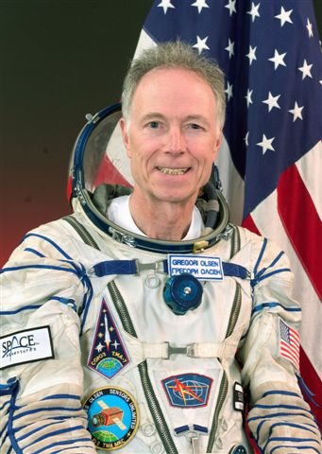
Greg Olsen founded EPITAXX, a fiber-optic detector manufacturer in 1984 together with Vladimir Ban. It was sold in 1990 for $12 million. He then founded Sensors Unlimited, a near-infrared camera manufacturer in 1992 with Marshall Cohen. Sensors was sold to Finisar Corp. for $600 million in 2000, repurchased by the management team in 2002 for $6 million, then sold again to Goodrich, Corp. in 2005 for $60 million. Greg was the third private citizen to orbit the earth on the International Space Station (ISS). After training for five months (900 hours) at the Yuri Gagarin Cosmonaut Training Center in Moscow, he launched on a Russian Soyuz rocket TMA-7 on October 1, 2005 with Cosmonaut Valeri Tokarev and Astronaut Bill McArthur (Expedition 12). He then docked to the ISS on October 3, and returned to earth on Soyuz TMA-6 on October 11 with Cosmonaut Sergei Krikalev and Astronaut John Phillips (Expedition 11). He performed more than 150 orbits of the earth and logged almost 4 million miles of weightless travel during his 10 days in space.

After an illustrious career as a research scientist and entrepreneur, Greg is now president of GHO Ventures in Princeton, NJ where he manages his “angel” investments, South African winery, Montana ranch, and performs numerous speaking engagements to encourage children – especially minorities and females- to consider careers in science and engineering. He is active in the New Jersey Technology Counsel (NJTC), NJTC Venture Fund, Institute of Electrical and Electronics Engineers (IEEE) and the NJ Commission on Science and Technology.

Greg received a BS Physics (1966), a BSEE and MS Physics (1968) from Fairleigh Dickinson University, then was awarded a Ph.D. in Materials Science from the University of Virginia (1971). He performed post-doctoral studies at the University of Port Elizabeth (South Africa), taught elementary physics classes, and then worked as a research scientist at RCA Labs (Sarnoff Center) from 1972 to1983. He developed vapor phase epitaxial crystal growth of optoelectronic devices, including laser diodes and photodetectors for fiber optic applications based on the material indium gallium arsenide (InGaAs). He was awarded 12 patents, wrote more than 100 technical papers, co-authored several book chapters and has given numerous invited lectures to both technical and trade journal audiences. Greg is an IEEE LEOS Fellow and the first recipient of the prestigious IEEE Aron Kressel Award.Greg is active in many civic organizations including Trenton Big Brothers and Sisters, Trenton Boys and Girls Club, Trenton Soup Kitchen, Princeton Historical Society, Custer Battlefield Preservation Committee and Fairleigh Dickinson University and University of Virginia Alumni Associations. In his spare time he enjoys golf, country and western music and dancing, opera and horseback riding.

Upcoming VANJ Luncheons
December 12, 2006 – Speaker To Be Announced

Please pre-register; an attendance list is distributed at the meeting. Use the form below and mail with your check payable to VANJ (charge for members is $35 and $55 for nonmembers), to be received no later than Monday (12 noon) before the meeting to VANJ, Box 1982, Morristown, NJ 07962-1982. Telephone reservations are taken only if mail would not be timely. Call Clara Stricchiola at (973) 631-5680, or fax your reservation to (973) 984-9634 / E-Mail: clara@vanj.com. Door Registrations/Late Registrations - $75
------------------------------------------------------------------------------------------------------------------------------------------------------------------
Yes, I will attend the November 21st Luncheon

Your Name: Title:

Company & Type of Industry:

Address City/State/Zip+4 code
Phone: Fax: E-Mail ___________________Amount Enclosed _______________
(Check One) Entrepreneur Investor/Lender Consultant Seeking New Job _____

