www.vanj.com
December 14, 2010
- Wayne Tamarelli, Ph.D., Angel Investor, President,
AWT Private Investments
Marriott Hanover, 1401 Rt. 10 East, Whippany, NJ Phone: 973-538-8811
https://www.marriott.com/hotels/maps/travel/ewrho-hanover-marriott/
Registration 11:30, Luncheon 12:00 noon – 2:00 PM

Venture Funders Should Be Asking: “Was Baron Rothchild Right?”

That 18th century British nobleman famously said “Buy when there is blood running in the streets”. The current “Great Recession” has put virtual blood in the streets. Venture funders (both entrepreneurs and investors) should be asking whether or not this provides exceptional opportunities.

Sources of venture funding, especially seed funding, are down. Valuations for startups are down. Does that mean it is a good time to start a business or invest in a business? If Baron Rothchild was right, this difficult environment may be a good time to fund ventures. Wayne Tamarelli will offer personal observations on these questions.
Wayne has made numerous angel and venture capital fund investments on both coasts and has managed businesses globally. He has over 40 years experience in entrepreneurship, general management, new ventures, mergers and acquisitions, advanced materials, environmental protection products, energy conservation technologies, specialty chemicals, technology transfer, angel investing, and other business and technological areas.
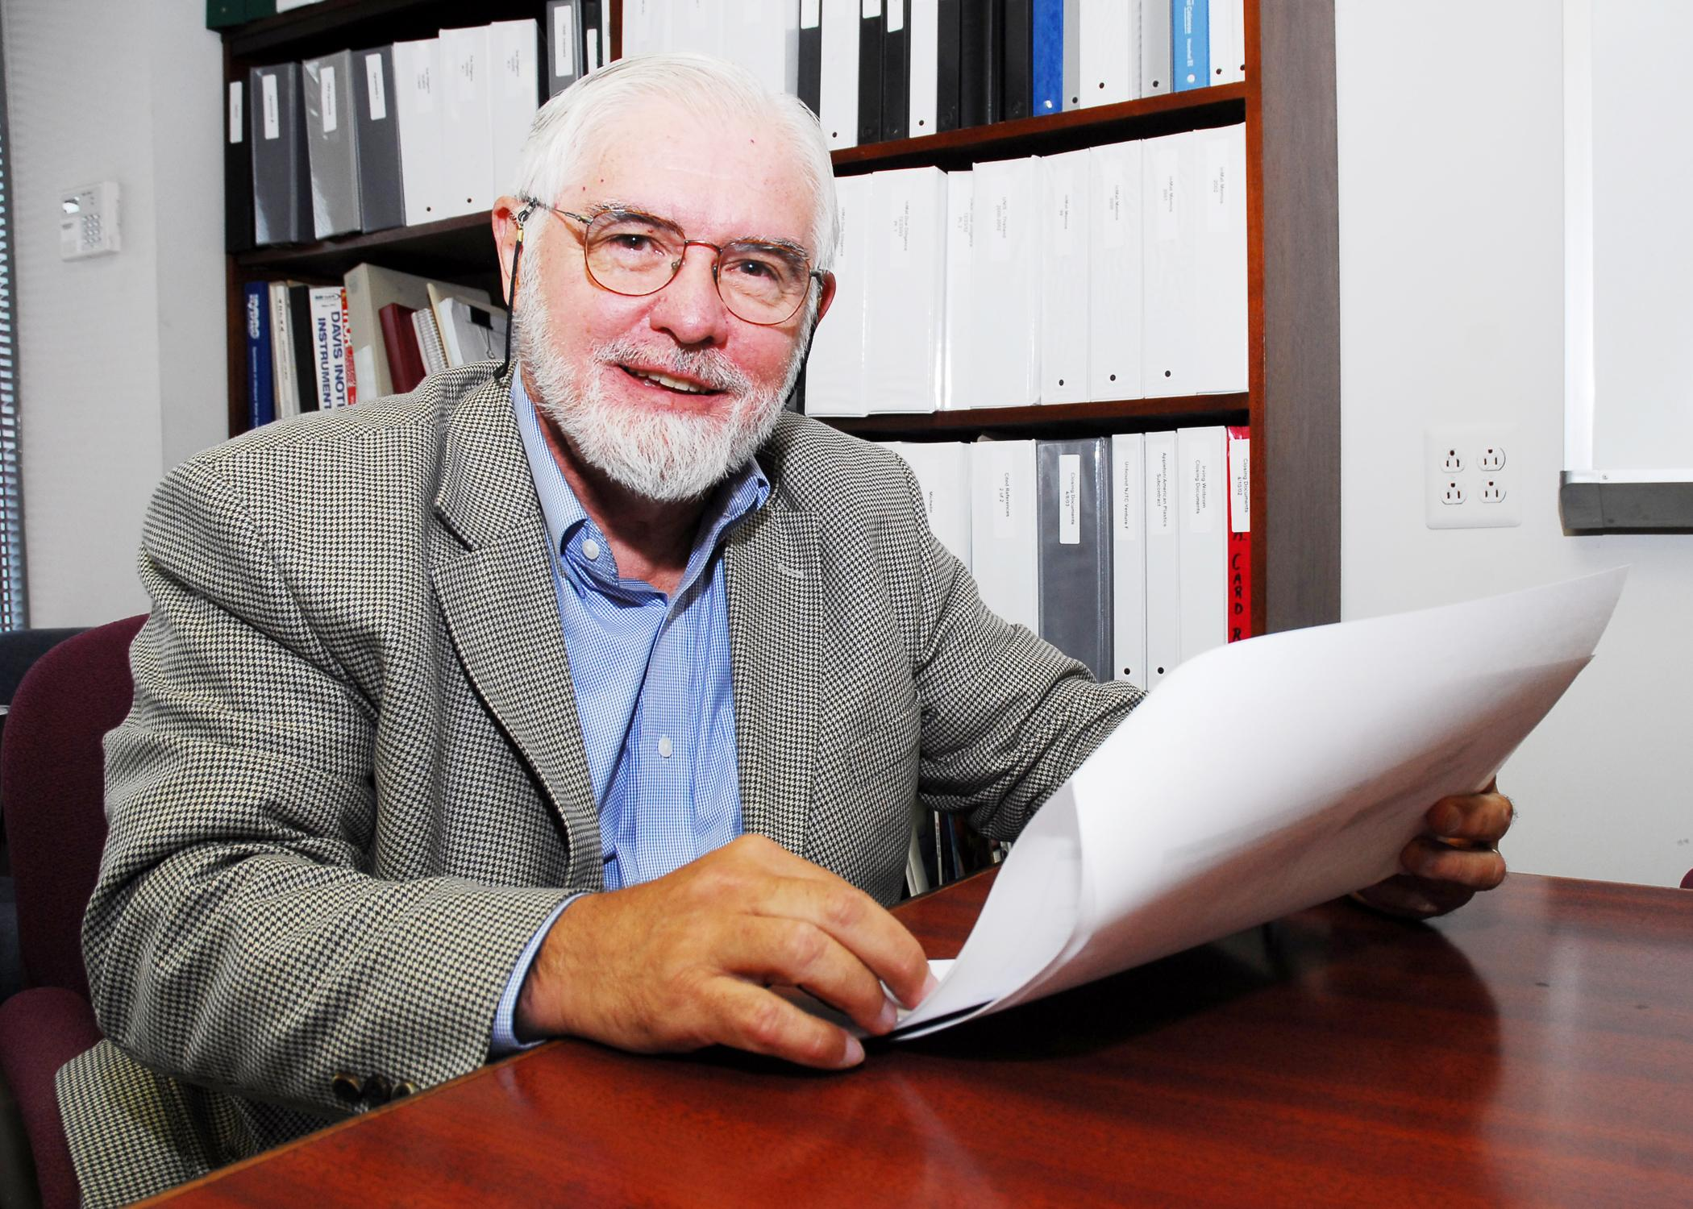

Wayne’s primary business activity is as a value-added angel investor in early stage technology businesses in the greater New Jersey and San Francisco Bay areas, making both active and passive investments. He serves on a number of boards of directors and advisory boards. In 1983 he purchased Dock Resins Corporation in a leveraged buyout and successfully grew its revenues and profits as Chairman, CEO and sole owner. In 1997 he sold the company at a substantial profit and remained CEO until 2000. He was with Engelhard Corporation from 1970 to 1983 as Senior Vice President where he managed $billion+ groups of worldwide businesses and also had senior management responsibility for corporate strategic planning and corporate R&D. He was an R&D manager at Exxon from 1966 to 1970. Earlier Dr. Tamarelli served as a captain in the U.S. Army and an engineering professor at Carnegie-Mellon University. He has BS, MS, and PhD degrees in engineering from Carnegie-Mellon University and an MBA in marketing and international business from New York University.
Upcoming 2011 VANJ Luncheons – Save The Dates
January 18, February 15, March 22, April 26, May 20-Expo, June 14, July 19, September 27, October 25, November 18-Expo, December 13

Please pre-register; an attendance list is distributed at the meeting. Use the form below and mail with your check payable to VANJ (charge for members is $35 and $55 for nonmembers), to be received no later than Monday (12 noon) before the meeting to VANJ, 26 Main Street, Chatham, NJ 07928-2402. Telephone reservations are taken only if mail would not be timely. Call Clara Stricchiola at (973) 631-5680, or fax your reservation to (973) 984-9634 / E-Mail: clara@vanj.com. Door Registrations/Late Registrations - $75
------------------------------------------------------------------------------------------------------------------------------------------------------------------
Yes, I will attend the December 14th Luncheon

Your Name: Title:

Company & Type of Industry:

Address City/State/Zip+4 code

Phone: _______ Fax: E-Mail ___________________Amount Enclosed _______________
(Check One) Entrepreneur Investor/Lender Consultant Seeking New Job _____

