VANJ’S 2011 Fall Entrepreneurs Expo

Elevator Pitch Olympics

Monday, November 14, 2011
Marriott Hanover
1401 Rt. 10 East, Whippany, NJ

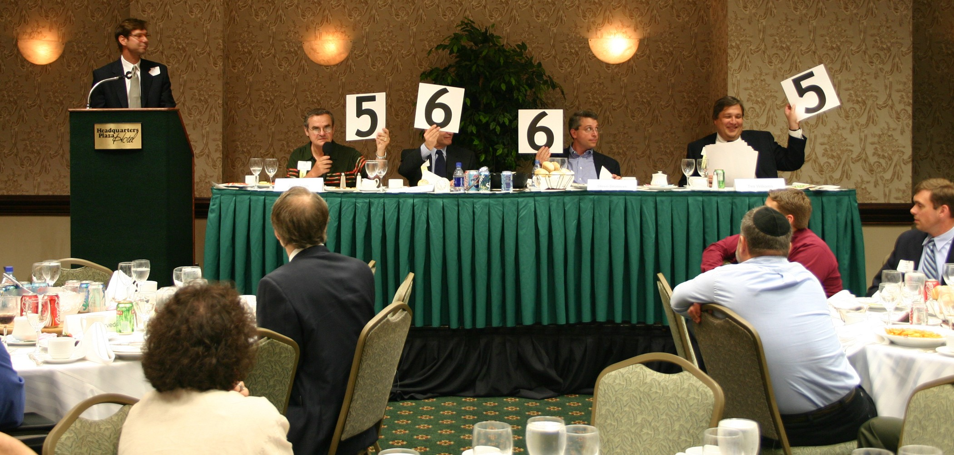
Take advantage of this opportunity to network with venture capital firms, angel investors, early stage startup companies, professional service providers, entrepreneurs and corporate licensing and strategic partnering executives.

Learn more about investing, corporate partnering, and technology licensing and acquisition opportunities.

At 10:00 AM the exhibit hall opens and as many as 30 companies that are seeking capital showcase their companies. At noon the luncheon program begins with our investor panel that focuses on the best ways for early stage companies to attract growth capital from angel or venture capital investors. The day’s luncheon program ends with the Elevator Pitch Olympics from 1:30 – 3:00 PM. The exhibits will open up again at 3:00 PM – 4:00 PM for further networking.

An elevator pitch is a short presentation made by an entrepreneur raising money for a venture. The term describes a pitch that’s short enough that it could be given during an elevator ride when the entrepreneur has the only chance to talk with a potential investor. Just as in the real Olympics, the investor judges hold up their scores and give points ranging from one to ten in the categories of quality of presentation and business fundability.

Marquee Sponsors

SorinRoyerCooper LLC

Trien Rosenberg
Trukmann's Reprographics

Sponsor
NJ Economic Development Authority

Morning Coffee Sponsor
Silicon Valley Bank

Media Sponsors
The NY Enterprise Report

Supporting Organizations
Connecticut Venture Group
Enterprising Solutions Inc.
Foundations Business
Development Group
Forest Hills Capital Management
FundingPost
NJSBDC
NJBIN
NJIT Enterprise Development Center
NJEF.org Entrepreneurs University
NJ Meadowlands Commission
Business Accelerator
New Jersey Technology Council
Pennsylvania Angel Network
Silicon Garden Angels +
Investors, NJ Angels.net
Rothman Institute of Entrepreneurship
Upstate Venture Association of NY (UVANY)

Investors
Efficiently invest your time to visit entrepreneur exhibits and hear the elevator pitches at one event.

Entrepreneurs
Network with Investors and learn from other entrepreneurs exhibits and elevator pitches.

Panelists & Elevator Pitch Olympic Judges
Moderator
David J. Sorin, Esq., Co-Managing Partner, SorinRoyerCooper LLC

Panelists
Joel Cartun, Angel Investor
Mario M. Casabona, Angel Investor, Founder & CEO Casabona Ventures, LLC
Larry A. Chaityn, Angel Investor, Managing Director – Kaminski Partners & President of The Keiretsu Forum
Carol Curley, Managing Director, Golden Seeds
David Drahms, Principal, Osage Partners
Arrun Kapoor, Managing Director, SJF Ventures
James G. Kollegger, CEO, Genesys Partners

(further panelists to be announced)

Monday, November 14, 2011
Marriott Hanover

Westin
9:00 am - 5:00 pm
Westin Hotel, 2 Whippany Road, Morristown, NJ

Company Exhibits 10:00 AM - 12:00 PM
3:00 PM - 4:00 PM

Luncheon Program & 12:00 PM - 3:00 PM

Elevator Pitch Olympics

ATTENDEE REGISTRATION

Company Exhibits and Luncheon Program: Register by mail using the form below. The cost is $75.00 (VANJ Members $50.00). Given the large turnout expected for the luncheon we may not be able to accept door registrations and reservations MUST be prepaid. Register early — last year’s luncheon was oversubscribed. Registrations after November 7th are door registrations and are $100.

View Company Exhibits: $25 - 10:00 AM – 12:00 Noon (Pre-registration Not Required)

For registration complete this form (or attach your business card), attach your check to VANJ for the proper amount and mail to VANJ, 26 Main Street, 3rd Floor, Chatham, NJ 07928-2402. Telephone, fax or e-mail reservations are possible, but your registration and payment for the luncheon must be received by Monday, November 7th . Please call Clara Stricchiola at 973-631-5680. or fax your registration to 973-984-9634 or email clara@vanj.com. (An attendance roster will be distributed.) Visit www.vanj.com to view pictures from previous events.

Fall 2011 Entrepreneurs Expo & Elevator Pitch Olympics Registration
($75 non-members; $50 members)
Monday, November 14, 2011
(Fill out this form or simply attach your business card)

I will attend the exhibits & luncheon ($75 non-members; $50 members)
(Please note, pitches are given by exhibitors only)
(Door Registrations $100-After Monday, November 7th)

Name & Title:

Company:

Address:

City, State, Zip:

Phone: Fax: Email:

Fee: $50 VANJ Members $75 Non-Members

(Circle One) Entrepreneur Investor/Lender Consultant Seeking New Job

