VANJ’S 2008 Spring Entrepreneurs Expo

Elevator Pitch Olympics

Thursday, May 22, 2008
Marriott Hanover
1401 Rt. 10 East, Whippany, NJ

Take advantage of this opportunity to network with venture capital firms, angel investors, early stage startup companies, professional service providers, entrepreneurs and corporate licensing and strategic partnering executives.

Learn more about investing, corporate partnering, and technology licensing and acquisition opportunities.

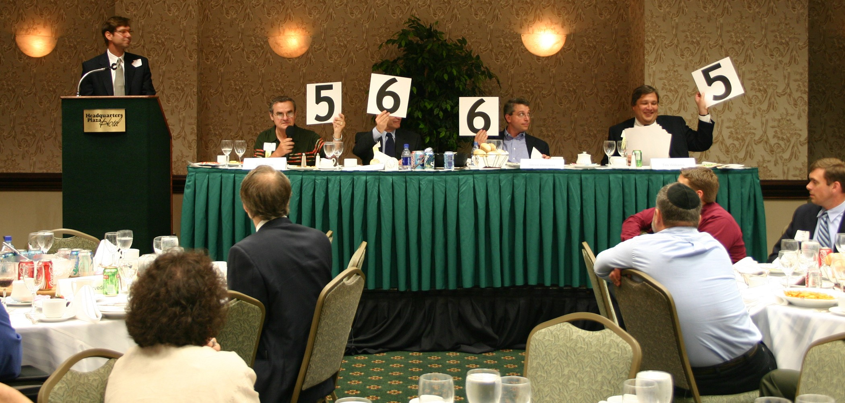

At 10:00 AM the exhibit hall opens and as many as 35 companies that are seeking capital showcase their companies. At noon the luncheon program begins with our investor panel that focuses on the best ways for early stage companies to attract growth capital from angel or venture capital investors. The day’s luncheon program ends with the Elevator Pitch Olympics from 1:30 – 3:00 PM. The exhibits will open up again at 3:00 PM – 4:00 PM for further networking.

An elevator pitch is a short presentation made by an entrepreneur raising money for a venture. The term describes a pitch that’s short enough that it could be given during an elevator ride when the entrepreneur has the only chance to talk with a potential investor. Just as in the real Olympics, the investor judges hold up their scores and give points ranging from one to ten in the categories of quality of presentation and business fundability.

Marquee Sponsors

Medallion Business Credit

NJBIZ

Thacher Proffitt & Wood LLP

Trien Rosenberg
TriNet
Virtudocs, Inc.

Sponsors
NJ Economic Development Authority

Supporting Organizations
Connecticut Venture Group
Enterprising Solutions Inc.
Forest Hills Capital Management
Foundations Business
Development Group
NJSBDC
FundingPost
NJIT Enterprise Development Center
NJ State Library
NJ Knowledge Initiative
NJEF
Pennsylvania Angel Network
Silicon Garden Angels +
Investors, NJ Angels.net
Rothman Institute of Entrepreneurial Studies
Upstate Venture Association of NY (UVANY)

Investors
Efficiently invest your time to visit entrepreneur exhibits and hear the elevator pitches at one event.

Entrepreneurs
Network with Investors and learn from other entrepreneurs exhibits and elevator pitches.

Panelists & Elevator Pitch Olympic Judges
Moderator – Leonard T. Nuara, Esq., Partner, Thacher Proffitt & Wood

Panelists
Ethan Ayer, Partner, Milestone Venture Partners
Charles Crockett, Partner, Ascend Venture Group
John Elton, Partner, iNovia Capital
Michael E. Helmer, Esq., Partner, Thacher Proffitt & Wood
Jeanne Sullivan, Founding Principal, StarVest Partners, L.P.
Tom Uhlman, Managing Partner, New Venture Partners

Thursday, May 22, 2008
Marriott Hanover

Westin
9:00 am - 5:00 pm
Westin Hotel, 2 Whippany Road, Morristown, NJ

Company Exhibits 10:00 AM - 12:00 PM
3:00 PM - 4:00 PM

Luncheon Program & 12:00 PM - 3:00 PM

Elevator Pitch Olympics

ATTENDEE REGISTRATION

Luncheon Program: Register by mail using the form below. The cost of the luncheon program is $75.00 (VANJ Members $50.00). Given the large turnout expected for the luncheon we may not be able to accept door registrations and reservations MUST be prepaid. Register early — last year’s luncheon was oversubscribed. Registrations after May 19th are door registrations and are $100.

View Company Exhibits: FREE 10:00 AM – 12:00 Noon (Pre-registration Not Required)

For luncheon registration complete this form (or attach your business card), attach your check to VANJ for the proper amount and mail to VANJ, Box 1982, Morristown, NJ 07962-1982. Telephone, fax or e-mail reservations are possible, but your registration and payment for the luncheon must be received within 7 business days before. Please call Clara Stricchiola at 973-631-5680. or fax your registration to 973-984-9634 or email clara@vanj.com. (An attendance roster will be distributed.) Visit www.vanj.com to view pictures from previous events.

Spring 2008 Entrepreneurs Expo & Elevator Pitch Olympics Registration
($75 non-members; $50 members)
Thursday, May 22, 2008
(Fill out this form or simply attach your business card)

I will attend the Luncheon Program ($75 non-members; $50 members)
(Please note, pitches are given by exhibitors only)
(Door Registrations $100-After May 19th)

Name & Title:

Company:

Address:

City, State, Zip:

Phone: Fax: Email:

Luncheon Fee: $50 VANJ Members $75 Non-Members

(Circle One) Entrepreneur Investor/Lender Consultant Seeking New Job

