March 22, 2011
www.vanj.com
Katherine O’Neill, Executive Director,
JumpStart New Jersey Angel Network
Marriott Hanover, 1401 Rt. 10 East, Whippany, NJ Phone: 973-538-8811
https://www.marriott.com/hotels/maps/travel/ewrho-hanover-marriott/
Registration 11:30, Luncheon 12:00 noon – 2:00 PM

How to Get a Check From an Angel
Katherine O’Neill is the Executive Director for JumpStart New Jersey Angel Network, a member led angel investor group that invests in early stage high growth companies in Mid-Atlantic region, and an investor in technology businesses. She currently serves on the Board of the Angel Capital Association ACA the national organization representing angel investor groups in North America. She is also the ACA Board liaison to the National Venture Capital Association (NVCA) board which represents the venture community in the United States. She recently was the Program Chair of the ACA National Leadership Conference held in 2010.
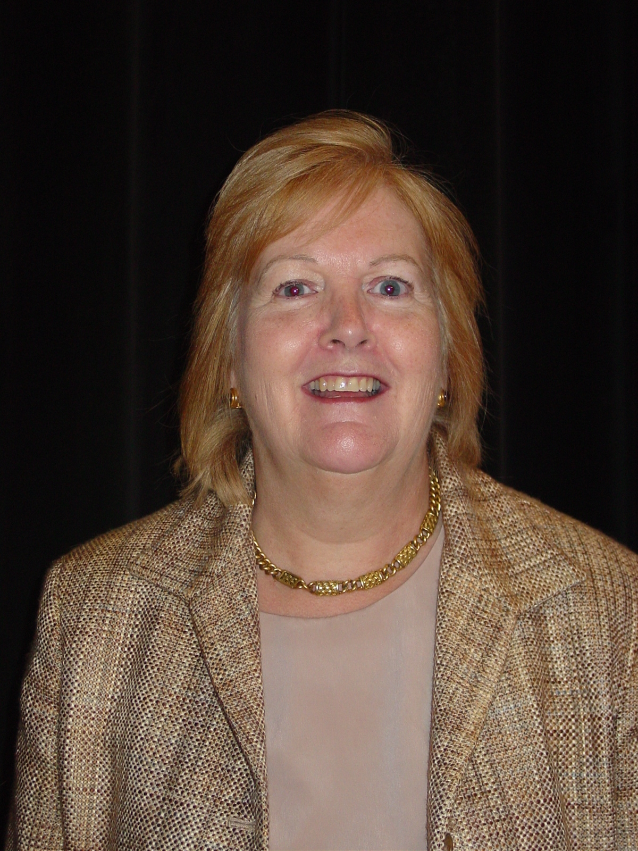
Katherine is a member of the NJ Economic Development Authority Edison Fund Advisory Board, NJ Technology CFO Advisory Board and Princeton University MIRTHE Investment Focus Group. In the last year she has spoken or judged business plan competitions both regionally and nationally at events such as PACT, Astia, Microsoft BizSpark NYC competition, Tri State Donald W. Reynolds Cup, Princeton University Jumpstart Innovation Forum and Angel Capital Association National Summit
Jumpstart was formed with the assistance of the New Jersey Technology Council and New Jersey Economic Development Authority. Jumpstart focuses on seed/early stage companies with core technology needing both funding and seasoned management assistance to move forward. Jumpstart actively looks for investments in the $200k-$1 Million range, and sometimes co-invests in larger investments with other angel groups or venture capital firms. Since 2004, Jumpstart has invested in over 32 companies in the Mid-Atlantic region.

Katherine is a seasoned financial executive and investor in early stage enterprises with extensive experience in start up and entrepreneurial operations as well as operational experiences in a diverse range of businesses. She has particular expertise developing technology-based business as well as strategic business plans, budgets, cash and tax planning and financials. She has extensive multinational experience and financial operation management and knowledge of healthcare pharmaceuticals, information systems, e-commerce and medical instruments and devices. She is the president of O’Neill Associates and consults with technology companies and acts as interim CFO.

In addition to her entrepreneurial activities, she was a senior executive in corporate finance in both a Fortune 100 pharmaceutical company and Fortune 500 chemical company. Katherine has served on many non-profit boards focusing on education and women in business. Katherine is also currently active with the Forum of Executive Women and on the Board at Merion Mercy Academy in Merion, PA.

Upcoming 2011 VANJ Luncheons – Save The Dates
April 26, May 20-Expo, June 14, July 19, September 27, October 25, November 18-Expo, December 13

Please pre-register; an attendance list is distributed at the meeting. Use the form below and mail with your check payable to VANJ (charge for members is $35 and $55 for nonmembers), to be received no later than Monday (12 noon) before the meeting to VANJ, 26 Main Street, Chatham, NJ 07928-2402. Telephone reservations are taken only if mail would not be timely. Call Clara Stricchiola at (973) 631-5680, or fax your reservation to (973) 984-9634 / E-Mail: clara@vanj.com. Door Registrations/Late Registrations - $75
------------------------------------------------------------------------------------------------------------------------------------------------------------------
Yes, I will attend the March 22nd Luncheon

Your Name: Title:

Company & Type of Industry:

Address City/State/Zip+4 code

Phone: _______ Fax: E-Mail ___________________Amount Enclosed _______________

(Check One) Entrepreneur Investor/Lender Consultant Seeking New Job _____

