www.vanj.com
December 13, 2011
- Wayne Tamarelli, Ph.D., MBA
Private Investor and President, AWT Private Investments
Marriott Hanover, 1401 Rt. 10 East, Whippany, NJ Phone: 973-538-8811
https://www.marriott.com/hotels/maps/travel/ewrho-hanover-marriott/
Registration 11:30, Luncheon 12:00 noon – 2:00 PM

New Tech Bubble? (Is it Champagne Bubbles or Sewer Gas This Time?)

Are we heading into a new Champagne Bubble environment that will make people rich? Or into a Sewer Gas environment that will make them poor? Can early stage businesses get the funding they need? Are some getting too much? What should entrepreneurs, angels, VC fund managers, professional advisors and others do in today’s investment climate?
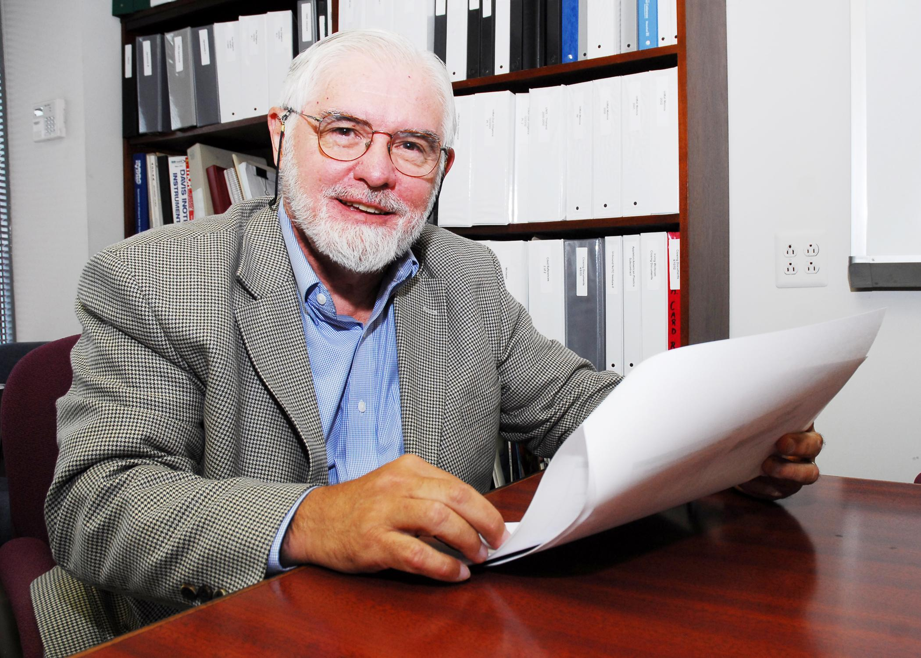
The overall economic climate is chilly and risky. Despite this the valuations of some startups have soared into the stratosphere. Others have languished or tanked. Dramatically new funding trends have emerged. Examples: Accelerators; Boot Camps; Superangels; startups being bought just to get the personnel; Crowdfunding; Startup Weekends; etc.
Wayne Tamarelli has witnessed and participated in numerous cycles in venture funding. He has seen entrepreneurs and investors celebrate after making excellent returns. Other times their efforts and money have gone down the drain.
Wayne has made numerous angel and venture capital fund investments on both coasts and has managed businesses globally. He has over 40 years experience in entrepreneurship, general management, new ventures, mergers and acquisitions, advanced materials, environmental protection products, energy conservation technologies, specialty chemicals, technology transfer, angel investing, and other business and technological areas.

Wayne’s primary business activity is as a value-added angel investor in early stage technology businesses in the greater New Jersey and San Francisco Bay areas, making both active and passive investments. He serves on a number of boards of directors and advisory boards. In 1983 he purchased Dock Resins Corporation in a leveraged buyout and successfully grew its revenues and profits as Chairman, CEO and sole owner. In 1997 he sold the company at a substantial profit and remained CEO until 2000. He was with Engelhard Corporation from 1970 to 1983 as Senior Vice President where he managed $billion+ groups of worldwide businesses and also had senior management responsibility for corporate strategic planning and corporate R&D. He was an R&D manager at Exxon from 1966 to 1970. Earlier Dr. Tamarelli served as a captain in the U.S. Army and an engineering professor at Carnegie-Mellon University. He has BS, MS, and PhD degrees in engineering from Carnegie-Mellon University and an MBA in marketing and international business from New York University.
Upcoming 2012 VANJ Luncheons – Save the Dates
Tuesday, January 31 – Tuesday, February 28 – Tuesday, March 20 – Tuesday, April 24 – Monday, May 21 (Expo)
Tuesday, June 19 – Tuesday, July 17 – Tuesday, September 11 – Tuesday, October 23
Monday, November 12 (Expo) - Tuesday, December 11

Please pre-register; an attendance list is distributed at the meeting. Use the form below and mail with your check payable to VANJ (charge for members is $35 and $55 for nonmembers), to be received no later than Monday (12 noon) before the meeting to VANJ, 26 Main Street, Chatham, NJ 07928-2402. Telephone reservations are taken only if mail would not be timely. Call Clara Stricchiola at (973) 631-5680, or fax your reservation to (973) 984-9634 / E-Mail: clara@vanj.com. Door Registrations/Late Registrations - $75
------------------------------------------------------------------------------------------------------------------------------------------------------------------
Yes, I will attend the December 13th Luncheon

Name: Title:
Company & Type of Industry:
Address City/State/Zip+4 code
Phone: _______ Fax: E-Mail _________________Amount Enclosed ____________
(Check One) Entrepreneur Investor/Lender Consultant Seeking New Job _____

